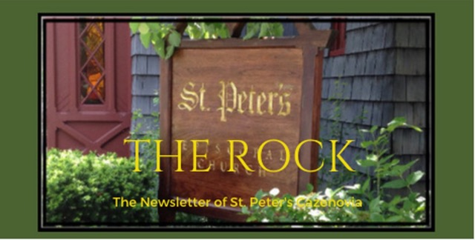

October 2023

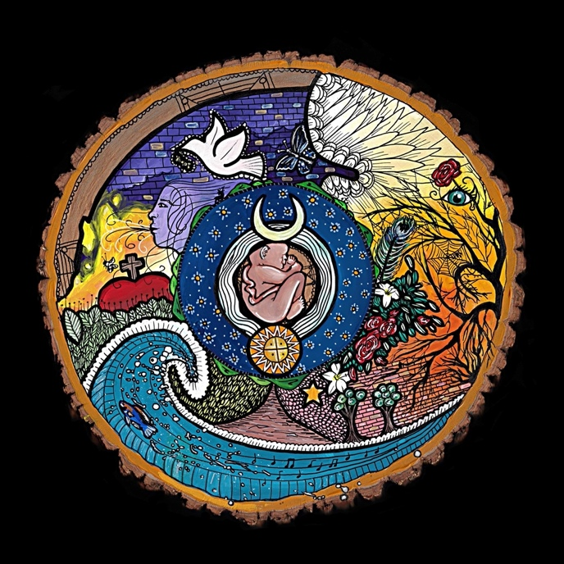

Art by Kristen Wheeler, moderniconographer.com

The heavens declare the glory of God; the skies proclaim the work of his hands. Day after day they pour forth speech; night after night they display knowledge. There is no speech or language where their voice is not heard.
Psalm 19:1-3

St. Peter’s News

A Message from our Rector

Dear Beloved of St. Peter’s,

It is beginning to look and feel like fall. Pumpkins and mums are adorning our doorsteps and pumpkin spice is adorning just about everything else! Many folks love October because of its crisp temperatures, blue skies, and brightly-colored leaves. While those are all reasons to enjoy this month, if you are an animal-lover, you might also love this month because it is when we celebrate the feast day of St. Francis of Assisi. Although he is known as the patron saint of animals and is probably one of the most popular saints, Francis’s story is much more complicated. Originally from a wealthy Italian family, in around 1208 he took a vow of extreme poverty and dedicated himself to a life of helping the poor. At a time when the Church reveled in its wealth, Francis challenged the status quo. He saw a need and responded to it by living his life in emulation of Christ.
So, while he may have truly preached to the animals during his travels, his ministry goes well beyond the Hallmark-card image that we often associate with him. He lived and preached an incarnational spirituality, in which everything (even the most humble) is imbued with the sacred presence. His “Canticle of the Creatures,” composed when he was almost blind, acknowledges, in exuberant language, the ways that God is glorified by the very elements of the earth. We bless the animals in recognition of this sanctity of all creatures, and as we do, perhaps we do well to also recognize that God blesses everything by God’s presence. Maybe Francis’s example calls us to look at the world with new eyes, to see God in all, and to see opportunities to serve God in unlikely places.
While Francis’s feast day is October 4, we will observe it by holding a brief liturgy on October 8 at 3:00 pm, followed by a blessing of the animals. All furry, finned, scaled, or feathered friends are welcome to attend. Through this awareness of God’s revelation in our humble (adorable) companions, perhaps our vision of the sacred will be expanded. Goodness knows, the blue skies and fiery leaves of fall seem to sing God’s praises — I imagine that our dogs and cats do, too!

With joy and love,
Rebecca+

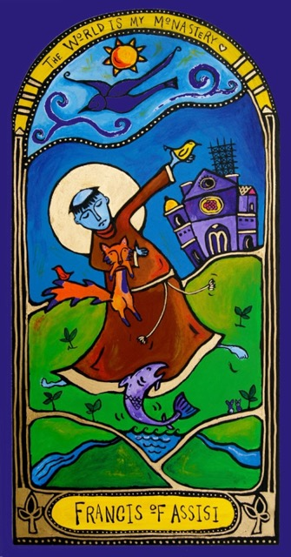

Canticle of Brother Sun and Sister Moon
St. Francis of Assisi

Most High, all-powerful, all-good Lord, all praise is Yours, all glory, all honor and all blessings.
To you alone, Most High, do they belong, and no mortal lips are worthy to pronounce Your Name.
Praised be You my Lord with all Your creatures,
especially Sir Brother Sun,
Who is the day through whom You give us light.
And he is beautiful and radiant with great splendor,
Of You Most High, he bears the likeness.

Praised be You, my Lord, through Sister Moon and the stars,
In the heavens you have made them bright, precious and fair.
Praised be You, my Lord, through Brothers Wind and Air,
And fair and stormy, all weather’s moods,
by which You cherish all that You have made.
Praised be You my Lord through Sister Water,
So useful, humble, precious and pure.
Praised be You my Lord through Brother Fire,
through whom You light the night and he is beautiful and playful and robust and strong.
Praised be You my Lord through our Sister,
Mother Earth
who sustains and governs us,
producing varied fruits with colored flowers and herbs.
Praise be You my Lord through those who grant pardon for love of You and bear sickness and trial.
Blessed are those who endure in peace, By You Most High, they will be crowned.
Praised be You, my Lord through Sister Death,
from whom no-one living can escape. Woe to those who die in mortal sin! Blessed are they She finds doing Your Will.
No second death can do them harm. Praise and bless my Lord and give Him thanks,
And serve Him with great humility.

Blessing of the Animals

On October 8 at 3:00 pm, we will gather in the grassy area behind Fellows Hall for a brief liturgy and blessing of the animals (we will move inside the parish hall if the weather requires it). All of your furry, finned, scaled, or feathered friends are welcome to attend. We ask that you maintain control of your pets at all times, by having them in a carrier, cage, or on a leash, for their safety and the safety of other pets.

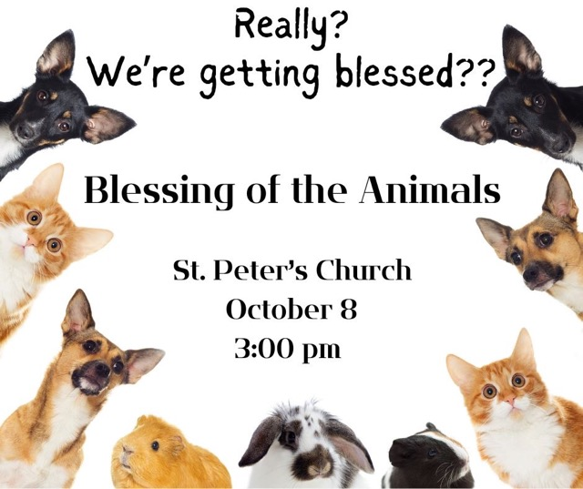

Saint Francis and the Season of Creation

Saint Francis (1181 or 1182-Oct. 3, 1226) was the founder of the Franciscan order. He was born in Assisi in central Italy in to wealth but was gradually converted to a life of radical simplicity, marked by poverty, humility, and contemplation of Christ. He gave generously to the poor and lived in poverty himself. He believed that all creatures are children of God. When others gathered around following him, wearing simple grey clothing, he founded an order of friars which became the Order of St. Francis. Women who also followed his beliefs and became called The Poor Clares.
Francis walked long distances, sharing the good news of God. Here is one story that shows how St Francis acted on his belief that all creatures are brothers and sisters under God.
“Father Francis and his companions were making a trip through the Spoleto Valley near the town of Bevagna. Suddenly, Francis spotted a great number of birds of all varieties. There were doves, crows and all sorts of birds. Swept up in the moment, Francis left his friends in the road and ran after the birds, who patiently waited for him.
“He greeted them in his usual way, expecting them to scurry off into the air as he spoke. But they did not move.
“Filled with awe, he asked them if they would stay awhile and listen to the Word of God. He said to them: “My brother and sister birds, you should praise your Creator and always love him: He gave you feathers for clothes, wings to fly and all other things that you need. It is God who made you noble among all creatures, making your home in thin, pure air. Without sowing or reaping, you receive God’s guidance and protection.”
At this, the birds began to spread their wings, stretch their necks and gaze at Francis, rejoicing and praising God in a wonderful way according to their nature. Francis then walked right through the middle of them, turned around and came back, touching their heads and bodies with his tunic.”
https://www.franciscanmedia.org/st-anthony-messenger/october-2017/st-francis-and-the-animals

Saint Francis (1181 or 1182-Oct. 3, 1226) was the founder of the Franciscan order. He was born in Assisi in central Italy. He was born in to wealth but was gradually converted to a life that believed in radical simplicity, marked by poverty, humility, and contemplation of Christ. He gave generously to the poor and lived in poverty himself. He believed that all creatures are children of God. When others gathered around followed him, wearing simple grey clothing he founded an order of friars, becoming the Order of St Francis. Women who also followed his beliefs and became called The Poor Clares.
Francis walked long distances sharing the good news of God. Here is one story that shows how St Francis acted on his belief that all creatures are brothers and sisters under God.
“Father Francis and his companions were making a trip through the Spoleto Valley near the town of Bevagna. Suddenly, Francis spotted a great number of birds of all varieties. There were doves, crows and all sorts of birds. Swept up in the moment, Francis left his friends in the road and ran after the birds, who patiently waited for him.
He greeted them in his usual way, expecting them to scurry off into the air as he spoke. But they did not move.
Filled with awe, he asked them if they would stay awhile and listen to the Word of God. He said to them: “My brother and sister birds, you should praise your Creator and always love him: He gave you feathers for clothes, wings to fly and all other things that you need. It is God who made you noble among all creatures, making your home in thin, pure air. Without sowing or reaping, you receive God’s guidance and protection.”
At this, the birds began to spread their wings, stretch their necks and gaze at Francis, rejoicing and praising God in a wonderful way according to their nature. Francis then walked right through the middle of them, turned around and came back, touching their heads and bodies with his tunic.”( https://www.franciscanmedia.org/st-anthony-messenger/october-2017/st-francis-and-the-animals)

The Eighth Sacrament
Coffee Hour is sometimes called the eighth sacrament of the Episcopal Church. There is truth hidden in this elevation of Coffee Hour to a sacramental status. Our Catechism describes a sacrament as an outward and visible sign of an inward and spiritual grace, given by Christ as a sure and certain means by which we receive that grace. When we share coffee and goodies and conversation, a sacred hospitality is offered, friendships are nurtured, grace and forgiveness may take place, pastoral care happens, and sharing in mutual joy creates deep connections.
Our coffee hour has been re-organized. There will be coffee, half and half, sweeteners, and – although home-made goodies are always welcome – store bought cookies in the kitchen. Please consider signing up to host a coffee hour. There is a sign-up sheet on the round table in the parish hall. If you need help or have questions, ask Diane, Lorie, Sarah, or Louise.

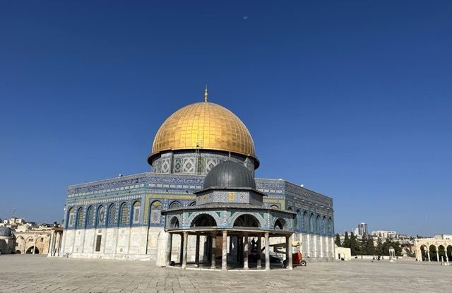

Trip to the Holy Land

In the late summer, some of our church family took a wonderful pilgrimage to the Holy Land. Together with Father Bob and Mother Eliza, Deede and McEwan and Gayonne and Wally visited many Biblical sites throughout Jerusalem.
In Deede’s words, “We watched the sun rise and celebrated communion in the desert, swam in the Sea of Galilee, floated in the Dead Sea, visited many beautiful and spiritual sites and made lots of wonderful friends. We started our trip with three nights at St. George’s Guest House in Jerusalem with day trips to many sights including Herodium, the palace built by King Herod, and the Church of the Nativity in Bethlehem. We headed north to Jericho, Nazareth, Capernaum and spent two nights at the Pilgerhaus Tabgha of the German Association of the Holy Land in Tabgha on the Sea of Galilee visiting sites in that area. We returned to St. George’s and spent an additional four nights where we visited the Western Wall, the Dome of the Rock, the Church of the Resurrection to the Holy Sepulchre, the Israel Museum, the Church of the Resurrection and wandered the streets of the Old City.”
Gayonne’s favorite experience was traveling to Wadi Qelt in the Judean Desert to watch the sunrise behind the mountains and sharing the Eucharist with their fellow travelers there. She writes that the Bedouin children seemed to appear from nowhere to sell wares of bracelets, scarves, and small rugs. She will carry this experience with her for the rest of her life.
Their last morning was spent walking the Stations of the Cross. For all of them it was a memorable trip, unlike any other. They are happy to share their experience and welcome questions from the rest of us.

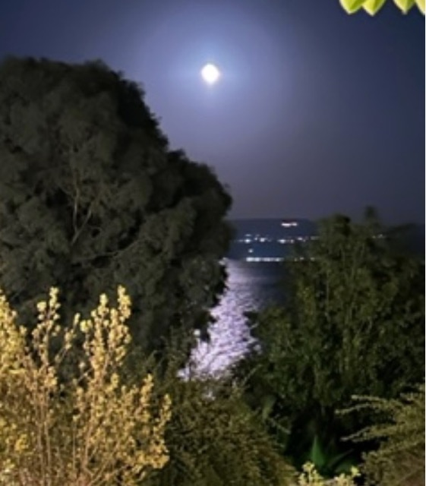

Members of our Congregation

Steve Evans

I was asked to write a narrative for this season of Creation Care regarding my affinity for growing trees. As I prepared this, I realized that, in fact, my interest in growing trees predates both the church season itself and any credible rationale for capturing carbon or stabilizing eroding hillsides. I think that my interest, which now could be credibly misconstrued as a do-gooder, tree-hugger desire comes from a lifelong interest in growing things with a clear understanding of how a little outdoor work at the outset can yield incredible dividends that pay off in both predictable and completely unexpected ways. But, I suppose it also is contributing in a very small way to Creation Care.
Growing up in East-Central Illinois, I helped with our small home gardens, but tomatoes and other home crops never interested me much. I liked working out in the large, complex farming operations nearby. I can remember believing early on that regional farmers' statements that "you could hear the corn grow on a hot day following rain" were, in fact, correct. The crackling leaves in the sun, and the white tips, where photosynthesis couldn't keep up with growth to maintain a uniform green plant were all the evidence that I needed. At that time, we lived in a nearby city, so my efforts to replicate exuberant growth of plants were small and limited, and even then trended towards trees in perhaps eccentric ways: planting peach pits in the front yard as a kid, and then dealing with neighbors' consternation as the resulting trees grew over 10 feet, laden with peaches, within a few years remains my favorite home "gardening" memory from that time.

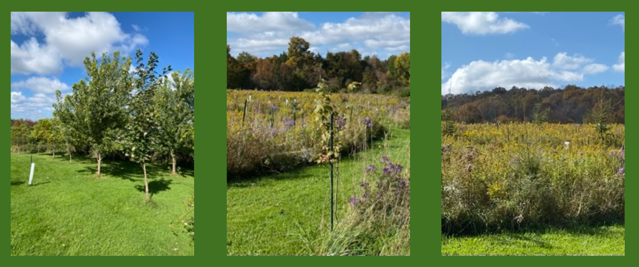

For the next 40 years, despite living in larger cities, I always tried to grow at least one cherry tree per house after we purchased our first home and raised our kids in different houses/yards in Buffalo. I occasionally exhibited tree-growing tendencies even then, as when I briefly planted an apple orchard in our front yard (it had the best sun and soil) on one of Buffalo's tonier streets. While the ensuing uproar among our neighbors remains a more humorous memory for me than Suzanne, it probably foreshadowed my efforts in New Woodstock.
Also in Buffalo, I supported the urban "Re-Tree" project there, hoping specifically to include blight-resistant American Chestnut trees developed at SUNY-ESF. In fact, during the first few winters in New Woodstock, I germinated American Chestnut seeds, planting the small numbers of successful seedlings outside, where the combination of our rocky, thin soil (not like East-Central Illinois at all) and ravenous voles caused both remarkable failure rates and serious upset on our hill...
With just enough early success among those tree-plantings, I looked for greener pastures, hopefully with better topsoil where I might experiment with a then-new concept in climate science called afforestation, the process of capturing carbon while planting a "forest" in what previously was a non-forest, usually a pasture. And, with further frustrating experimentation, I realized that the best terrain to try this project would be on the steepest, thinnest, and of course most unfriendly parts of our property, where erosion already threatened to form gullies that would eventually undermine our house.
So, with my planting experience and the need to stabilize the hill adjacent to our house, I embarked on what is now a six-year project, planting between 1,000 and 1,500 seedlings per year on a 9 acre plot that I now aspirationally call "mein Baumgarten" (my tree garden) in deference to our property's association with the L. Frank Baum family! With an approximate 10-15% failure rate among these seedlings during their first year, we have around 8,000 trees now, about 500 of which are now taller than the pasture grass in which they're growing.
As you can see from some of the images of the project, trees, when protect from marauding voles, insatiable deer, and our high winds until they reach about six feet, will in fact grow pretty well out here and stabilize the hillside, reducing erosion and keeping the miniscule amounts of remaining topsoil in place. Measuring the carbon capture from such a project and ascribing a metric of reduction in overall climate change is impossible, even if some small advantage accrues to the environment. For me, though, it provides endless walks and fun work. It's an ongoing battle against other creatures who want to eat parts of trees, but fun, and certainly one that I'm winning more than losing as I evolve my processes while doing something for Creation Care!

Ministries and Committees

News from the music gallery
St. Peter’s choir is back in the swing, singing anthems, hymns and canticles. This October, choir musicians who also play instruments will provide Offertory, prelude and postlude music, starting with our October 1st service.
We rehearse every Thursday evening at 7 and our doors are open for everyone who is willing to join!

St. Peter’s Concert Series is scheduled for Saturday, October 28th at 4 PM. The program is titled: “Sonatas and Trios” and will feature Symphoria musicians Yurie Mitsuhashi in violin, Willian Ford-Smith in viola and our own Ida Tili-Trebicka in piano. The program includes music by Schubert, Mozart, Shostakovich etc.

We accept Donations at the door. Any amount is much appreciated and needed to help with the cost of the concert. If you want to sponsor the concert or any of the musicians, please contact Ida @ 315-254-0614 or Gretchen at the Parish Office.
This will be an outstanding concert, so please spread the word around and invite friends and family to attend.

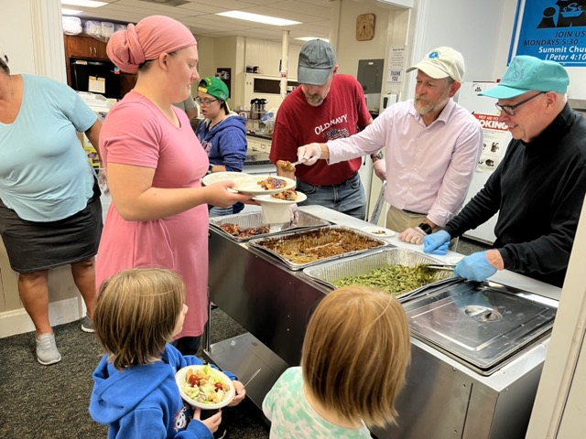

The Friendship Inn

Did you know The Friendship Inn is a shared ministry of St Peter’s Church and other local churches? The second Monday of every month, some of our members serve a nutritious meal to people who live in our community. There is no charge for this meal, and there is no income requirement. In this time when the surgeon general of the United States and our Bishop both are concerned about an epidemic of loneliness pervading our country, the Friendship inn provides a caring community. It is sponsored by Summit Church and is located at the Methodist Church. It is open on Monday evenings from 5:30 to 7:00.
Presently, the Friendship Inn is financed through donations only. All the food that is served is prepared in the commercial kitchen that is located in the Methodist Church.

For more information, please check with our regular volunteers, Rick or Tim.

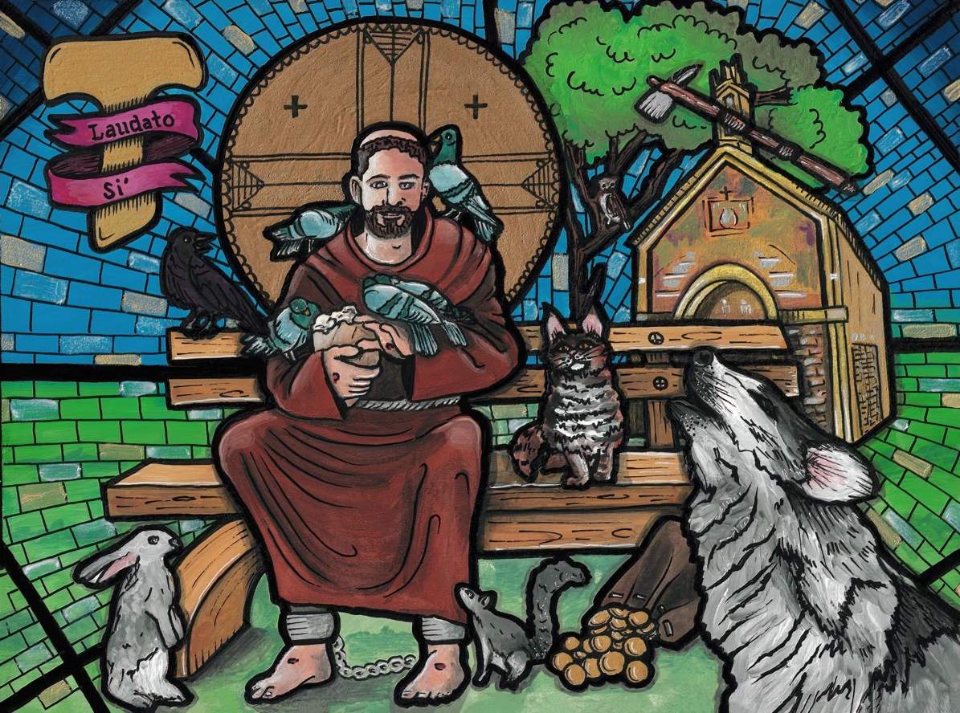

Art by Kristen Wheeler, moderniconographer.com

Greetings from the Vestry!

The Vestry met on September 20th. The energy and work of the committees is amazing! For example, the Buildings, Gardens, and Grounds (BGG) Committee has a list of projects, but a critical need is to replace the deteriorating, ice-prone, heel-grabbing, uneven courtyard between the sanctuary and the Parish Hall building. This is one of those long-standing capital projects discussed before, and the Vestry has decided it is a priority. You will see more about that in the near future, but meanwhile, ideas and donations for that cause are WELCOME.

Speaking of stewardship, that is not just a “fall thing”, but it is a constant celebration of abundance. We are incredibly blessed!

One aspect of St. Peter’s that many people have worked very hard to steward for many years has been The Key. Thank you to the wonderful people who are working at The Key now and who have worked there and/or volunteered there in the past. However, the Vestry is discussing whether all of that energy, time and resources can be used to serve God in new and re-energizing ways. Here too, ideas are welcome.

We continue to welcome new people as well as welcome back people who are returning. Continue to share the Good News!

The Nominating Committee for proposing new Vestry members to the parish is up and running. That committee is led by McEwan. Thank you to Marti, Cyndi and Bob for agreeing to serve on that committee. If you are interested in serving on the Vestry or on any of the committees (Hospitality, Communications, BGG, Worship, Altar Guild and Finance) please let me or McEwan know. We are also interested in starting up an audit committee to internally review and audit finances and processes. Again, let us know of your interest.

Thank you!
Cynthia Maxwell Curtin,
Senior Warden

News of St. Peter’s and the Greater Community

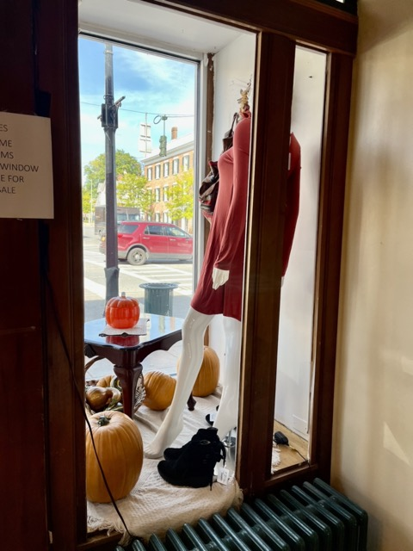

The Key is getting ready for our approaching winter season. Soon, it will be collecting warm clothing. Right now, the windows are decorated for fall and back to school clothing is still available. The basement is full of small furniture and housewares at bargain prices.

The Key has been St. Peter’s main ministry for years. It provides neighborhood shopping of good clothing and housewares at bargain prices, while its consignors are able to add a bit to their incomes. Students from Cazenovia High School who volunteer at the Key receive school credit for community service. Caz Cares and The Key are sometimes able to cooperate in finding appropriate professional clothing for their customers. Still, The Key is struggling. Our church and community are not providing enough volunteers and The Key’s income is no longer able to support giving financial aid to any community organizations as it has in the past.

Rev Rebecca and our vestry would appreciate ideas from members of our church family.

The food item we are collecting in October is spaghetti sauce.

We are also looking for donations of adult or children’s winter outer wear. If you can help, please drop it off at Caz Cares on Mondays, Tuesdays, and Thursdays from 9:30 to 12:00 at Caz Cares, or place it in the collection shed by Caz Cares.

Thank you for helping to keep everyone in Cazenovia warm!

A good number of Cazenovians attended the September presentation on end-of life paperwork sponsored by CRIS and St Peter’s Church and asked a record number of questions. There is one more presentation in this Death and Dying Speaker Series. On Monday October 23rd, five professionals from Hospice of CNY will describe its services. The presentation will be from 10:00 am until noon in the community room of the Cazenovia Library.
On October 11, the Madison County Office of the Aging will be hosting its annual Senior Fair at Theodore Restaurant in Canastota from 10:00 am until 1:00 pm. Information pertaining to seniors from different agencies and health care facilities will be available. If you have any questions, please ask Chris or check the CRIS website.

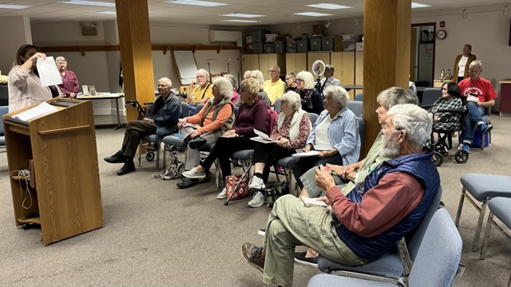

Diocesan News

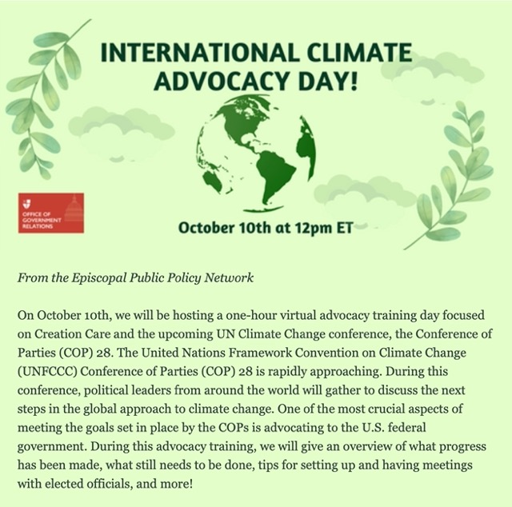

Calendar

Events in October
1 10:00 am Sunday Service followed by Coffee Hour and Adult Formation
2 10:00 am Bone Builders (Parish Hall)
3 9:00 am Bible Study (classroom by Parish Hall)
4 Feast of St. Francis of Assisi
noon Noonday Prayer with Centering Prayer
5 10:00 am Bone Builders (Parish Hall)
7:00 pm Choir Practice
8 10:00 am Sunday Service followed by Coffee Hour and Adult Formation
3:30 pm Blessing of the Animals (grassy area behind Fellows Hall)
9 10:00 am Bone Builders (Parish Hall)
5:00 pm Volunteer Day at the Friendship Inn
8:00 pm AA Meeting (Parish Hall)
10 9:00 am Bible Study (classroom by Parish Hall)
11 noon Noonday Prayer with Centering Prayer
12 10:00 am Bone Builders (Parish Hall)
7:00 pm Choir Practice
15 10:00 am Sunday Service followed by Coffee Hour and Adult Formation
16 10:00 am Bone Builders (Parish Hall)
17 9:00 am Bible Study (classroom by Parish Hall)
18 noon Noonday Prayer with Centering Prayer
19 10:00 am Bone Builders (Parish Hall)
7:00 pm Choir rehearsal
22 10:00 am Sunday Service followed by Coffee Hour and Adult Formation
23 10:00 am Bone Builders (Parish Hall)
10:00 am CRIS series on Death and Dying (Cazenovia Public Library)
24 9:00 am Bible Study (classroom by Parish Hall)
25 noon Noonday Prayer with Centering Prayer
26 10:00 am Bone Builders (Parish Hall)
7:00 pm Choir rehearsal
28 4:00 pm St. Peter’s Concert Series “Sonatas and Trios”
29 10:00 am Sunday Service followed by Coffee Hour and Adult Formation
30 10:00 am Bone Builders (Parish Hall)
31 9:00 am Bible Study (classroom by Parish Hall)

__________________________________________________________________________________________

Copyright © 2023 St. Peter’s Episcopal Church, all rights reserved

Our mailing address is:
St. Peter’s Episcopal Church
10 Mill Street
Cazenovia, NY 13035
315-655-9063

Email us at:
parishoffice@stpeterscaz.org
Find us at:
www.stpterscaz.org

