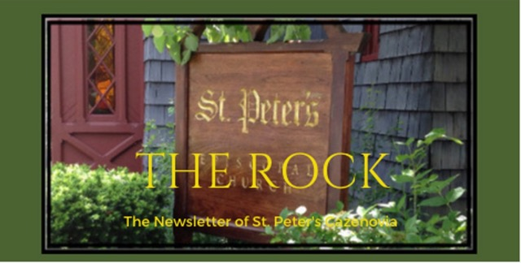

November 2023

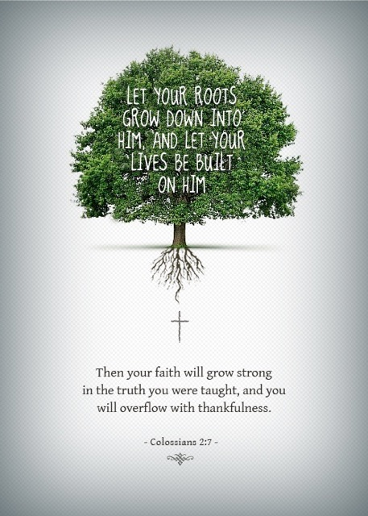

This month marks the one-year anniversary of Reverend Rebecca coming to St. Peter’s. We are most grateful that she answered our call. It has been a wonderful year of working in collaboration and community, (re-) discovering our gifts and celebrating in gratitude. Her guidance and teachings have been inspirational and invigorating. We are looking forward to many more years together.
Thank you, Reverend Rebecca!

St. Peter’s News

A Message from our Rector
Beloved of St. Peter’s,
Blessings on you in this season of saints and stewardship. When I began serving as your rector last year on November 1st, I felt that beginning work on that feast day was particularly appropriate. All Saints (November 1) and All Souls (November 2) are both days when we remember those who have gone before us — both the beloved saints of the church and our own beloved dead. We were also right in the middle of our stewardship campaign when I arrived. Stepping into the role of rector is in itself a form of stewardship. We come in for a time and care for this place, with its storied past and its rich history. Each person who has served this church before me has been a part of that stewarding, as have all of its members of ages past and present. We work for the good of this church, and we also work for the good of this community. Ultimately, as Christians, we are to work for the good of this world. In times of difficulty and peace, we come together to support one another and those in need, and my prayer is that for ages to come we will continue to do that good work. Time brings changes and opportunities — may our hearts be open to God’s work through us and God’s possibilities before us. Thank you for your love and fellowship in our first year together.
With peace and gratitude,
Rebecca+

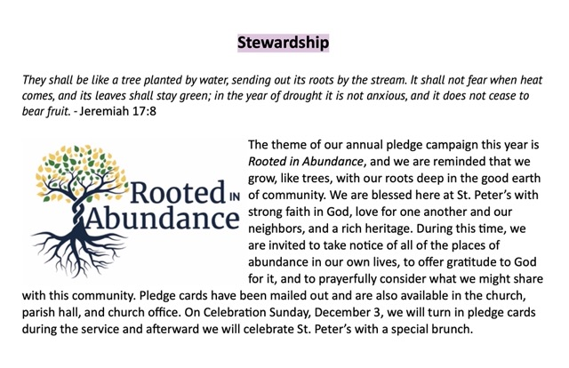

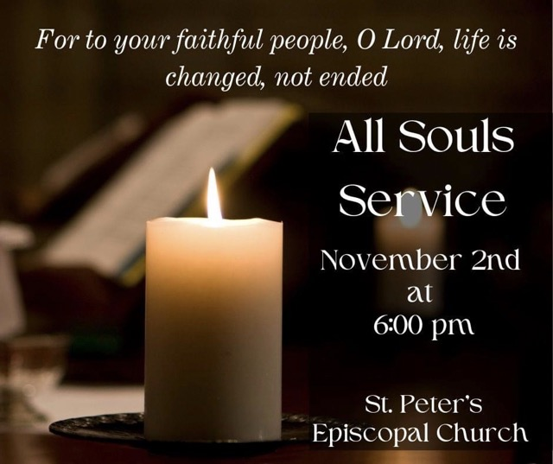

Have a Good Triduum!

The month of November begins with a triduum, Hallowe’en (All Saints Eve), All Saints’ Day, and All Souls Day.
Known as Allhallowtide, this triduum begins on 31 October. It is a time to remember the dead, especially martyrs and saints, but also all faithful departed Christians. The present date, November 1, of Hallowmas (All Saints' Day) and thus also of its vigil, October 31, (Hallowe'en) was established for Rome perhaps by Pope Gregory III in 835. In the early 11th century, the modern date of All Souls' Day, November 2, was popularized, after Abbot Odilo established it as a day for the monks of Cluny to pray for the dead.
All Hallows' Eve, popularly known as Halloween, is the eve of All Saints’ Day. (Over

hundreds of years and influenced by superstitions and ancient beliefs, our modern Halloween is celebrated with costumes, parades, and offerings of food.) All Saints’ Day is a holy day to honor all the saints and martyrs. The final day of Allhallowtide is known as All Souls’ Day and is also called the Commemoration of All Faithful Departed. All Souls’ Day focuses on honoring all faithful Christians, especially family members and friends, who have died.
A triduum in the Christian church is a special three day period, always harkening back to our history of martyrs, most especially Jesus Christ. Our primary triduum is the Paschal triduum that lasts from the eve of Holy Thursday to Easter Eve.

Church Field Trip
St. Matthew’s Episcopal Church, Moravia, NY
St. Matthews Church is arguably the most uniquely beautiful church in our Diocese. It was built in the 1820’s, consecrated by Bishop John Henry Hobart, the founder of Hobart College, and is decorated with extraordinary Bavarian Oak carvings. It is near the rustic birth place of Millard Fillmore who was married there.

Members of St. Matthew’s have offered to give us a guided tour, tell us about their church’s history and show us the art work
Friday morning, November 10th
10:30 AM
Please let the church office or Louise know if you would like to go on this trip. We will meet in the church parking lot at 9:15 to drive together.

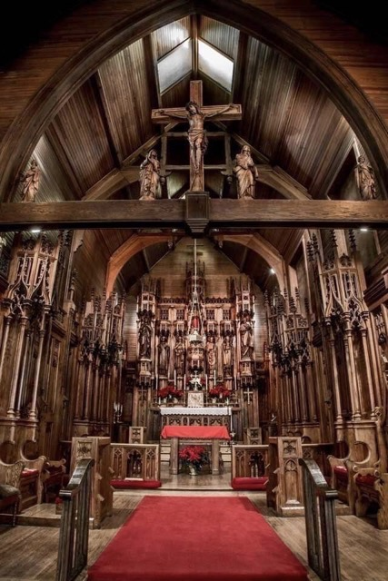

Members of our Congregation

We are filled with gratitude for Diane, Sarah, and Lorie. They have reinvigorated our coffee hour, aka “the 8th sacrament”. It is now again a wonderful time of hospitality and connection among long time, new, and returning members of our church family, visitors and guests.
Each of these three women brings special talents to this ministry. Diane shares her superb table setting skills, Sarah a love of delicious food, and Lorie her gift of organization. Already, under their leadership, we have had new hosts, a variety of delicious treats, and new connections and friendships.

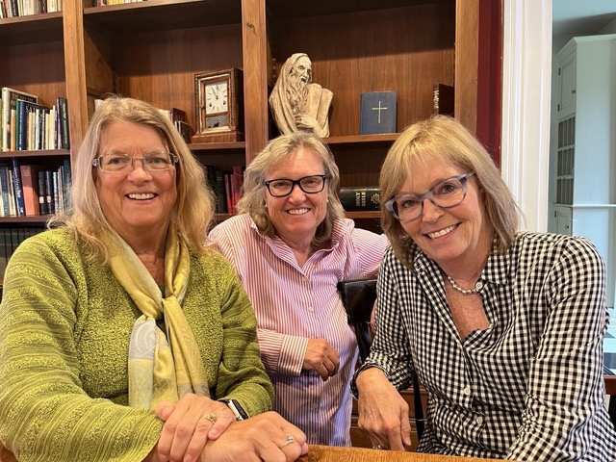

Please sign up to host a Sunday coffee hour. It’s extra nice to host with a friend. Our expert coffee maker guide, Louise, is almost always available to help if you need a bit of support. There is a sign-up sheet and hosting directions on the round table in the parish hall. Directions for using the coffee maker are posted in the kitchen.

Ministries and Committees

Pastoral Care Ministries
Pastoral care is an ancient model of emotional and spiritual support found in all cultures and traditions. At St. Peter’s our pastoral outreach committees try to cover needs of parishioners, who are active in church activities, or who are home bound. The pastoral care committees and contact people are as follows:
Overall Chairperson - Chris. Contact her if you have concerns or questions
Prayer Circle - Marti. The prayer circle consists of 9 “prayer warriors,” who pray for special prayer requests and needs. Shared information is confidential.
Meals - Chris and Marti. Meals will be provided for folks recovering from medical procedures and who need a little help from their friends.
Outreach - Chris and Louise. Church information and goodies will be brought to parish members who are unable to attend regular church services and activities, helping to keep them in the loop.
Receptions - Chris and Marti. Receptions may be set up for families after special life services including funerals and weddings.
If you have ideas, questions, or wish to volunteer in any of these ministries please contact Rev. Rebecca or Chris.
Written by Chris

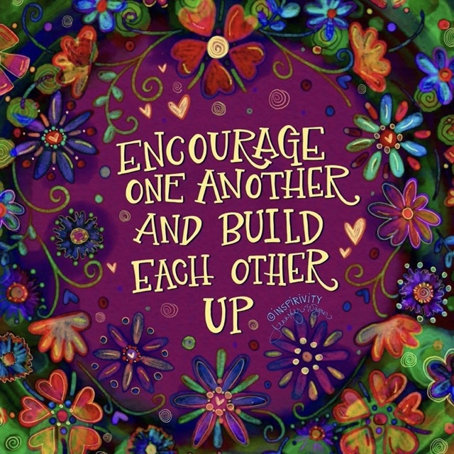

News from the music gallery

On Saturday, October 28th, we witnessed in delight a concert of St. Peter’s concert Series with the trio Yurie Mitsuhashi on violin, Jordan Gunn on cello and Ida Tili-Trebicka on piano. We had a very enthusiastic and appreciative audience of about 70 people. Many thanks to all who helped, attended and donated.
November is the last month of church year A, and we will enter Year B on Advent 1 on December 5th.
Musicians of St. Peter’s have been practicing and playing at services. We have been treated to music by flute, violin, cello by our own Meredith, Beverly and Steve. There is more special music to come in November while we are getting ready for advent.

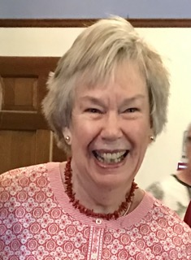

Ida, counting her choir blessings in this month of gratitude, is highlighting choir member Judy.
Judy is our choir librarian and a devoted chorister in the soprano section. Her knowledge of the liturgy and hymns is invaluable. We are grateful for your service to St. Peter’s, dear Judy! Music has always been a big part of Judy’s life. She remembers, “I sang in the chorus through upper school. Singing was also a big part of my family’s holiday gatherings. I recall how after dinner my family gathered around a piano and my aunt played while everyone sang.
“During his lifetime, my husband Charlie was also an enthusiastic member of St. Peter’s choir for many years. I am eternally grateful to Ida and the choir for the music at Charlie’s memorial service. It was magnificent!”

Written by Ida and Judy

Greetings from the Vestry!

The Vestry met on October 18, 2023.

One of the issues that came before us is “the tree”—the beautiful but drainage encroaching and gutter filling tree by the entrance to Fellows Hall. After consulting tree people and those with expertise in the Parish, the best course of action is to remove it. But, as usual, the BG&G committee has some great plans for what to grow in that space which will be beautiful and not problematic. Thank you to those who took on this tough issue and to Stan for dealing with the problems that this tree has presented over the years.

Speaking of thanks, I am thankful for the sisters and brothers on the Vestry and in this wonderful Parish. The abundant talent and gifts so generously shared reveals how we are truly rooted in abundance. I am reminded of a hymn from my growing up years: “Thank you, God, for sisters, brothers keeping faith with us and you, joining heart to heart with others so your call to us comes true.” [Lyrics by Roger K Powell]

Thank you!
Cynthia Maxwell Curtin,
Senior Warden

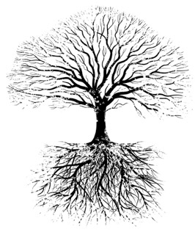

News of St. Peter’s and the Greater Community

Jack-o’-lanterns are on the wane at The Key as Dolli and the staff prepare for Thanksgiving. Consignors and donators are asked to bring in decor, household goods, clothes, and other items that relate to Thanksgiving. And speaking of being thankful, the two weekend high school girls who work at The Key expressed how much they enjoy their jobs here. One of them loves everything about clothes, including selling them, while her friend especially loves the environmental benefits of buying and selling used clothing.

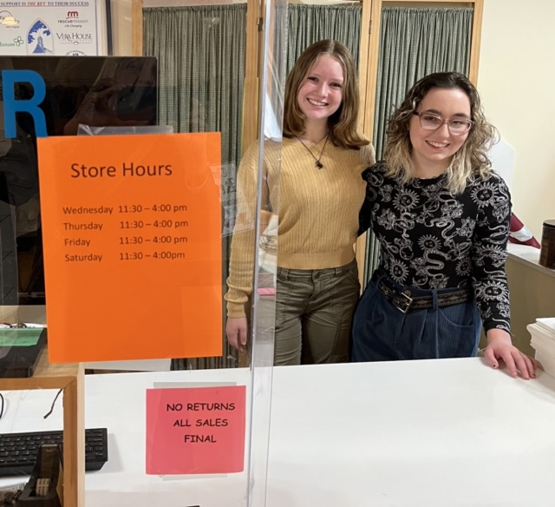

Dolli also reminds us that Christmas is coming and that special events and sales will be taking place starting in the middle of this month.

November and December are always Caz Cares’ busiest months of the year. This year, Thanksgiving baskets will be distributed to families on Saturday, November 18th, from 9:00 am until 12:30. We’re asking members of St. Peter’s to participate in this fun and heart-warming event. Make sure you dress warmly for the weather.

This month, we’re collecting pasta. Please put your donations in the basket in the parish hall.
Thank you for your continued support!

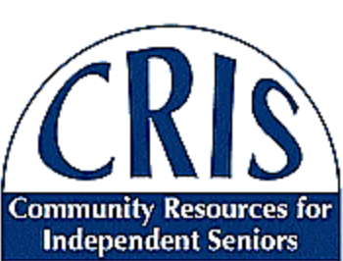

CRIS and St. Peter’s Church held their last presentation in the “The Death and Dying” speaker series. Caregivers from Hospice spoke on the variety of services they offer. This series, CRIS and St. Peter’s first collaboration, was very well attended and informative. Because of its popularity, CRIS would like to hear from you if there are other topics you would like to know more about. If you have one, please call or email CRIS (315-655-5743 or director@cris-caz.com).

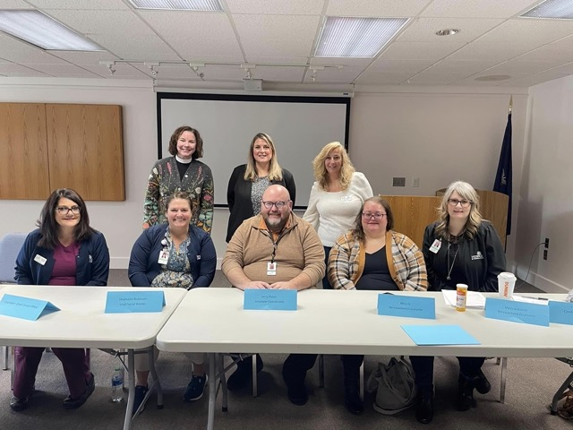

On November 15th, CRIS will be stuffing 300 bags with information about how to assist seniors to continue having a productive and independent life. This activity will take place in our parish hall between 9:00 am - 2:00pm. If you are interested in helping, please contact Chris.

Diocesan News

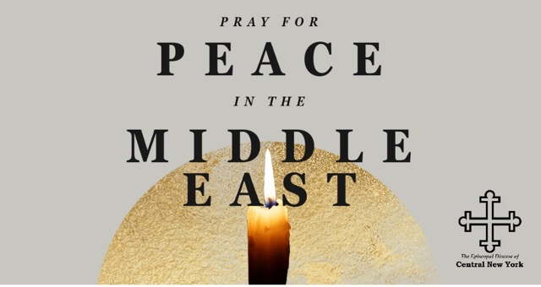

A Call to Prayer

“People of faith and goodwill can organize and address our governments to call for humanitarian aid to flow freely to those in desperate need in Gaza; for the release of all hostages; for an end to all targeting of children and other civilians; and for a de-escalation of violence in the West Bank and East Jerusalem."
- Presiding Bishop Michael Curry

The escalation of violence in the Holy Land continues, with what the BBC described as “total chaos” in Gaza after a night of bombing and a ground invasion.

In this moment of violence and destruction, we urge you to lift your voices and strongly urge the President and your representatives in Congress call for a humanitarian truce, as voted for by the United Nations General Assembly. Desperately needed humanitarian aid must reach the people of Gaza so that more life is not lost.

We also urge all of you to pray. We pray for God’s comfort and mercy to reach all those who are afraid, who suffer and are in pain, who grieve, and those who have been cut off from loved ones.

In his opening remarks to Executive Council this past week, Presiding Bishop Michael Curry said, “Prayer matters and makes a difference. We must pray. So, pray for wisdom and moral courage for world leaders so that violence does not beget more violence—because violence doesn’t work, and violence will not bring about a just and sustainable and enduring peace.”

From the Episcopal Public Policy Network

Calendar

Events in November
1 noon Noonday Prayer with Centering Prayer
2 10:00 am Bone Builders (Parish Hall)
6:00 pm All Souls Service
7:00 pm Choir Practice
5 10:00 am Sunday Service followed by Coffee Hour (Parish Hal) and
Adult Formation: Practicing our Faith
6 10:00 am Bone Builders (Parish Hall)
5:00 pm Volunteer Day at the Friendship Inn
8:00 pm AA Meeting (Parish Hall)
7 9:00 am Bible Study (classroom by Parish Hall)
8 noon Noonday Prayer with Centering Prayer
9 10:00 am Bone Builders (Parish Hall)
7:00 pm Choir Practice
10 9:30 am Field Trip to St. Matthew’s, Moravia
12 10:00 am Sunday Service followed by Coffee Hour (Parish Hall) and
Adult Formation: Practicing Our Faith
13 10:00 am Bone Builders (Parish Hall)
14 9:00 am CRIS Bag Stuffing in Parish Hall
15 noon Noonday Prayer with Centering Prayer
16 10:00 am Bone Builders (Parish Hall)
7:00 pm Choir rehearsal
18 9:00 am Caz Cares Thanksgiving Food distribution to Families
19 10:00 am Sunday Service followed by Coffee Hour (Parish Hall) and
Adult Formation: Practicing Our Faith
20 10:00 am Bone Builders (Parish Hall)
21 9:00 am Bible Study (classroom by Parish Hall)
22 noon Noonday Prayer with Centering Prayer
23 Thanksgiving
26 10:00 am Sunday Service followed by Coffee Hour (Parish Hall) and
Adult Formation: Practicing Our Faith
27 10:00 am Bone Builders (Parish Hall)

28 10:00 am Bible Study (classroom by Parish Hall)
29 noon Noonday Prayer with Centering Prayer
30 10:00 am Bone Builders (Parish Hall
7:00 pm Choir rehearsal

__________________________________________________________________________________________

Copyright © 2023 St. Peter’s Episcopal Church, all rights reserved

Our mailing address is:
St. Peter’s Episcopal Church
10 Mill Street
Cazenovia, NY 13035
315-655-9063

Email us at:
parishoffice@stpeterscaz.org
Find us at:
www.stpterscaz.org

