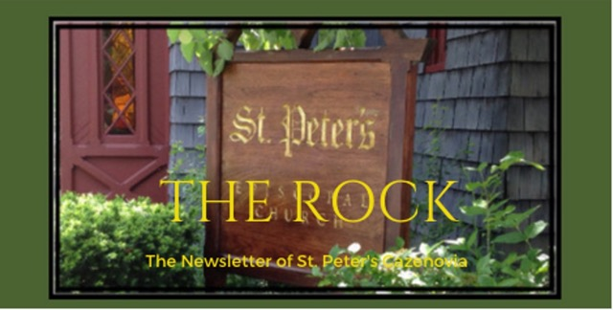

March 2024

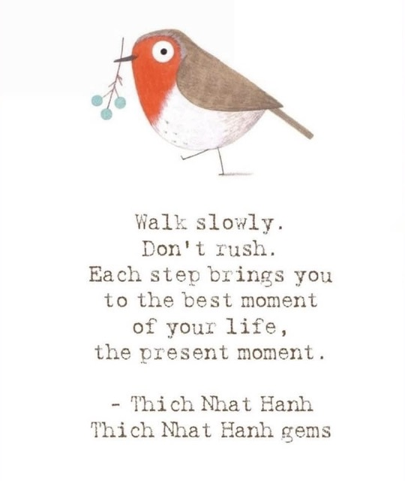

St. Peter’s News

A Message from our Rector
Beloved of St. Peter’s,
The weather as I write this letter to you is beautiful enough to convince me that it is already spring. However, after only one year here, I know that snow is always right around the corner here in Central New York. Yet, we have hope. Even as we await the springtime snow storms, we know that the flowers will bloom and the sun will shine again. The weather this time of year is a good analogy for the season of Lent and the coming of Easter — even as we wander in the desert, we anticipate the glory of those living waters freed by the resurrection. We are an Easter people. That does not mean that life is always easy or that we cultivate a false positivity, but it does mean that we have hope when we are in the midst of difficulty.

Liturgically, in the month of March, we will celebrate Jesus’ triumphal entry into Jerusalem on Palm Sunday and then quickly shift to the Passion narrative, we will remember Jesus’ last meal with the disciples, wait with Him in the garden, and then walk with Jesus to the cross. Finally, on the last day of the month, we will rejoice. We have weeks to go before we get there, but we continue looking ahead. May the month to come bring us into a deeper walk with Jesus, even as we traverse our own deserts, and may we all find our hope and joy renewed at Easter.

Blessings on the journey,
Rev. Rebecca

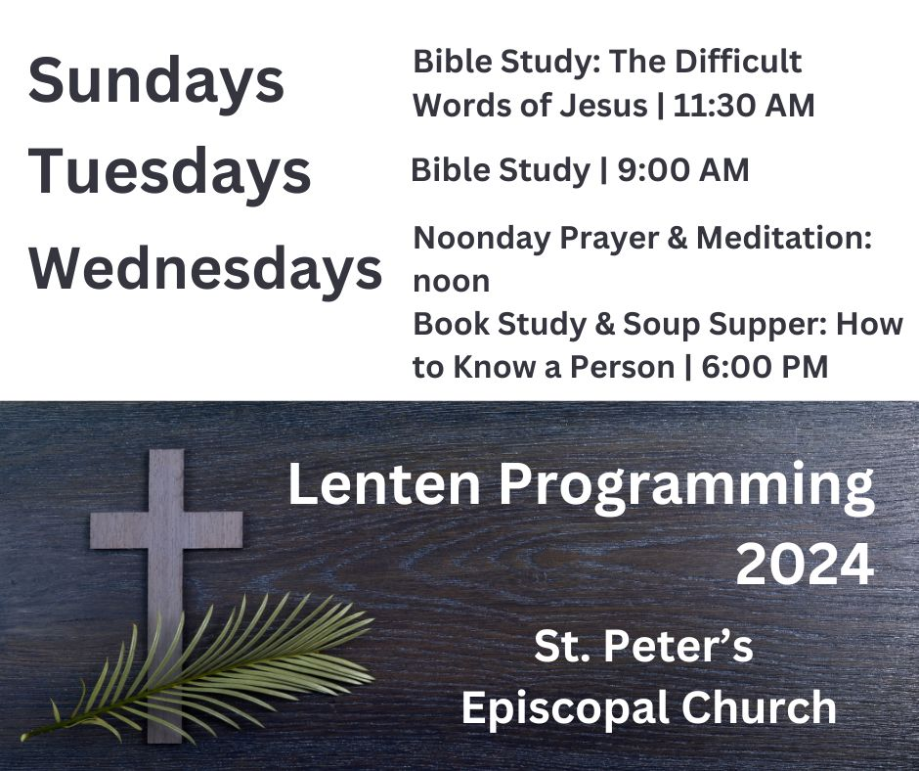

The holiest Triduum

We learned about the sacred triduum in November – Hallowe’en (All Saints Eve), All Saints’ Day, and All Souls Day. This month, we will experience the Paschal Triduum, the holiest three days of our church year – Maundy Thursday, Good Friday, and The Easter Vigil. St. Peter’s will celebrate Easter Day rather than the vigil on Holy Saturday.

The Paschal Triduum has been observed since the earliest Christian times. During these three days we will gather on Maundy Thursday to remember the time Jesus

washed his disciples’ feet, teaching them to love one another, the time of their last supper together, Jesus’ prediction of his betrayal, and his lonely night of prayer just before his arrest. On Good Friday we solemnly commemorate his death on the cross. During the Easter Vigil, Episcopalians traditionally re-tell the entire history of their sacred story and re-commit themselves to their Baptismal vows to follow the Way of Jesus. On Easter Day, we celebrate Jesus’ Resurrection. As we re-tell these sacred stories, we move through a sad and dark time, renew our own commitment, receive Jesus in bread and wine, and become Easter people who carry light out into our world.

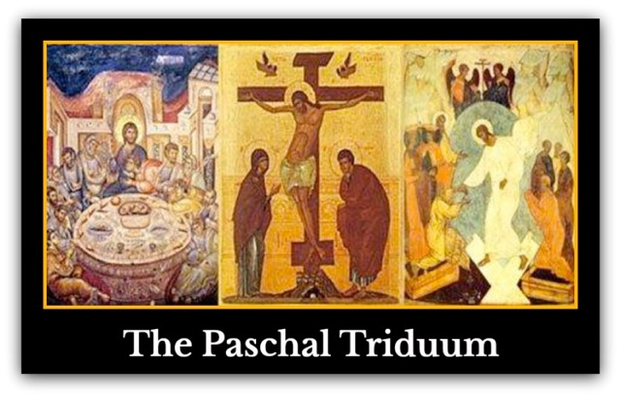

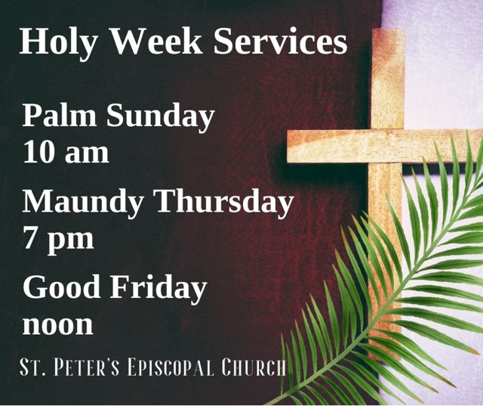

How does the Vestry Work?

According to The Episcopal Dictionary, “the vestry is the legal representative of the parish with regard to all matters pertaining to its corporate property. The presiding officer of the vestry is the rector. There are usually two wardens. The senior warden leads the parish between rectors and is a support person for the rector. The junior warden often has responsibility for church property and buildings.” It goes on to say, “The basic responsibilities of the vestry are to help define and articulate the mission of the congregation; to support the church’s mission by word and deed, to select the rector, to ensure effective organization and planning, and to manage resources and finances.”

To some of us, part of the definition may be surprising. Rev. Rebecca is our vestry’s leader or presiding officer. This description goes on using words like “usually” or ”basic”. Canon laws of the Episcopal Church allow dioceses and individual churches to determine much- how many members are on the vestry, when the vestry is elected, and particular responsibilities of its members.

Our vestry has 8 elected members. There are also a clerk and a treasurer/s that are appointed by the rector and vestry. These members are part of our church family and we all need to engage with the vestry in working toward the vitality of our church. Our vestry clerk (recorder) is Sharon Cooney. Our treasurers are Bev Brown and Beverly Fernagut. Pictures of the vestry members are shown below.

Usually, our vestry meets on the 3rd Wednesday of the month, at 7:00, in the parish library. Members of our church family are welcome to attend meetings. In order to bring up a discussion or present an idea at a vestry meeting, you must speak with Rev Rebecca or a vestry member first to make sure it can be added to the meeting agenda. Both concerns and new ideas are welcome.

Our 2024 Vestry

McEwan Van der Mendele Suzanne Evans
Sr Warden Jr Warden

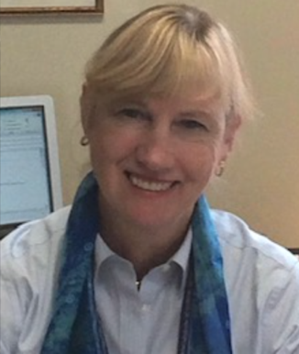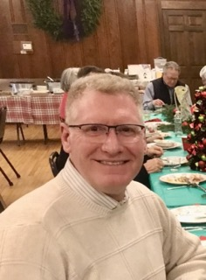

Timothy McKay Cynthia Maxwell Curtin Timothy Galbreath
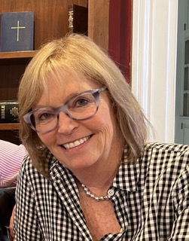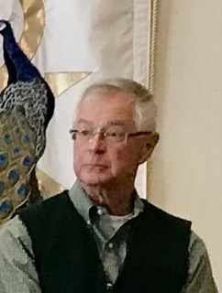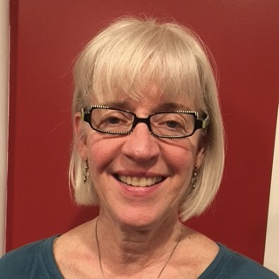

Lori Riedl Rick Lounsbury Betsy Moore

Clerk and Treasurers

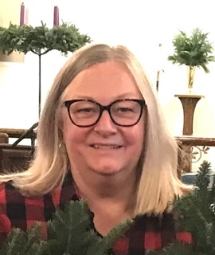

Sharon Cooney Bev Brown Beverly Fernagut
Clerk Treasurer Treasurer

Ministries and Committees

What Does Ministry Look Like?

Ministries are actions we take to serve a church’s mission in some way. The mission of St. Peter’s Church as stated prominently in our Sunday bulletin is, “To grow God’s image and spread Christ’s Kingdom through the power of the Holy Spirit.” That

sounds daunting. How do we do that? This season of Spring and Easter is a good time renew our ministry work. We have ministries that take place right in our church such as altar guild, lay readers, and ushers. We have ministries, such as easel displays and improving our buildings and grounds, that reach out to our community. We share in the outreach of many community organizations such as Caz Cares, The Friendship Inn, CRIS, and CWR. We have participated in diocesan ministries, like racial reconciliation, and donated to national and international organizations such as The Red Cross, Mission of Miracles, and Ukrainian relief. And of course, Rev. Rebecca and all of us are ministers for Jesus wherever we are.

Right now there are two new ministries developing in our church. We are, happily, preparing to staff our nursery. There is also a need for volunteers who can help with shoveling our walks and entrances when Stan is not available or needs assistance. If you are interested in volunteering, please contact Rev Rebecca.

Our church has so many ministries that can use all kinds of our personal talents and time. There is bound to be one for each of us. Check out our new ministry bulletin board, in the Parish Hall, to find more about St. Peter’s ministries. If you have an idea for a new ministry, especially one that you would like to participate in, Rev. Rebecca and our vestry members would love to hear about it.

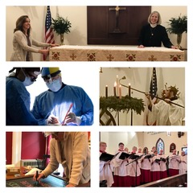

Greetings from the Vestry

During our February vestry meeting, we welcomed our new vestry members Lorie and Rick.

While we are off to a good start financially and all is going well with the endowment since the transfer of our accounts to ECF, our average Sunday attendance has also been up.

Replacement of pavers in the Columbarium Courtyard has been funded and work will begin when supplies are in and weather permits (but not during Holy Week). Replacement of windows at 10 Mill Street will happen in phases with the front facing windows as the first priority. The committee will work to get an estimate for replacing all 38 windows.

The first listening session for the status of The Key was well-attended. Several parishioners have expressed their surprise about The Key’s situation. Another listening session will be held on March 17 at noon with Rev. Steve White as facilitator. This session will focus on the finances of The Key.

Notes from the music gallery

For the remainder of Lent, our music includes canticles and anthems that reflect the season of penance and reflection. Instead of Gloria and Alleluia, we sing the Introit Kyrie “Lord have mercy”.

On Palm Sunday, we meet in Fellows Hall (the parish hall) before the service for the blessing of the palms followed by a processional with special music to the front door of the church.

Holy week music includes a Maundy Thursday foot-washing anthem and hymns. The absence of music is what makes the somber stripping of the altar an even more meditative and striking ritual at the end of this special service.

Easter Sunday is a celebration with Alleluias! The Syracuse Orchestra quartet will be playing as the congregation and choir rejoice by singing Easter anthems and hymns.

Members of our Congregation

Stephanie
This month we’re introducing someone who you might have encountered upon coming to church, at any time during the week, in the kitchen on the floor, in a cabinet, or on top of a counter. Here a little about Stephanie in her own words:

My husband Jeff and I have three adult children, Sarah who lives on Bainbridge Island, WA, Alex who works with Jeff at the lumber yard we own - Chittenango Lumber- a 67yr old family business, and Lillie our youngest who lives in Denver while attending Grad School at DU.
I love to travel and explore. Jeff and I

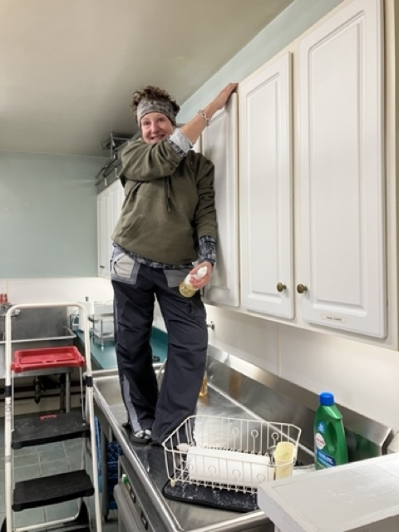
have three adult children, Sarah who lives on Bainbridge Island, WA, Alex who works with Jeff at the lumber yard we own - Chittenango Lumber- a 67yr old family business, and Lillie our youngest who lives in Denver while attending Grad School at DU.
I love to travel and explore. I’m quite the collector of rocks and sea treasures. My favorite place in the world is Maine. Maine has lots of places to explore and lots of treasures to bring home. I have a rock wall at my house. I picked and placed every rock when we were building two years ago and I just keep adding to it. I worked for US Airways for 25 years right up to 9/11. Over a year ago I decided to return to church but knew I didn’t want to return to the Catholic Church, so I started exploring. I was so impressed with Rev. Rebecca after two zoom services and talking to friends that I knew this is where I want to be. I’m thankful to God that this is where he led me. I’ve always been involved with volunteering my time when and where I can. When one Sunday I volunteered for coffee duty, well, all I can say is that kitchen was in need of some cleaning. So here I am, your Kitchen Witch. I really enjoy hanging out at the church cleaning. I get to talk with Stan, Rev Rebecca and most of all God. Amen 🙏

News of St. Peter’s and the Greater Community

During March, we are collecting canned tuna for CazCares. Thank you for giving so generously!

Calendar

Events in March
3 10:00 am Sunday Service followed by Coffee Hour (Fellows Hall) and Study of
The Difficult Words of Jesus by Amy-Jill Levine (classroom by FH)
4 10:00 am Bone Builders (Fellows Hall)
5 9:00 am Bible Study (classroom by Fellows Hall)
6 noon Noonday Prayer with Centering Prayer
6:00 pm Soup Supper & Study of How to Know A Person by David Brooks
7 10:00 am Bone Builders (Fellows Hall)
6:00 pm Healing Service
7:00 pm Choir Practice
10 Beginning of Daylight-Saving Time (spring ahead)
10:00 am Sunday Service followed by Coffee Hour and Study of
The Difficult Words of Jesus by Amy-Jill Levine (classroom by FH)
11 10:00 am Bone Builders (Fellows Hall)
12 9:00 am Bible Study classroom by Fellows Hall)
13 noon Noonday Prayer with Centering Prayer
6:00 pm Soup Supper & Study of How to Know A Person by David Brooks
14 10:00 am Bone Builders (Fellows Hall)
7:00 pm Choir Practice
17 10:00 am Sunday Service followed by Coffee Hour Parish Hall) and Study of
The Difficult Words of Jesus by Amy-Jill Levine (classroom by FH)
18 10:00 am Bone Builders (Fellows Hall)
19 9:00 am Bible Study (classroom by Fellows Hall)
20 noon Noonday Prayer with Centering Prayer
6:00 pm Soup Supper & Study of How to Know A Person by David Brooks
21 10:00 am Bone Builders (Fellows Hall)
7:00 pm Choir Practice
24 10:00 am Palm Sunday - Meet in Fellows Hall followed by Coffee Hour and
Study of The Difficult Words of Jesus by Amy-Jill Levine
25 10:00 am Bone Builders (Fellows Hall)
26 9:00 am Bible Study (classroom by Fellows Hall)
27 noon Noonday Prayer with Centering Prayer
6:00 pm Stations of the Cross (Fellows Hall)

28 10:00 am Bone Builders (Fellows Hall)
7:00 pm Maundy Thursday Service with Foot-washing and Stripping of the Altar
all night Gethsemane Watch
29 noon Good Friday Service
31 10:00 am Easter Sunday Service with special music followed by celebratory
coffee hour

__________________________________________________________________________________________

Copyright © 2023 St. Peter’s Episcopal Church, all rights reserved

Our mailing address is:
St. Peter’s Episcopal Church
10 Mill Street
Cazenovia, NY 13035
315-655-9063

Email us at:
parishoffice@stpeterscaz.org
Find us at:
www.stpterscaz.org

