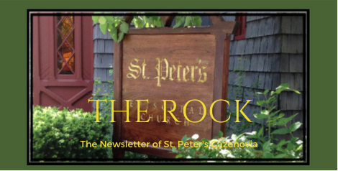

June 2023

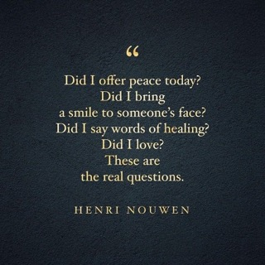

St. Peter’s News

A Message from our Rector

Dear Friends in Christ,

Happy Pentecost & season after! One of my favorite days in the church year is Pentecost. There is something compelling about the movement of the Holy Spirit and how it cannot be contained. Also, the way that the Spirit made (and makes) the gospel available to everyone, lies at the heart of our faith. The message proclaimed by Peter in the Book of Acts was not just for a select group, despite presupposed expectations. Rather, it was extended equally, as was God’s love through the Spirit. Not only were language barriers broken down on that day, but so were all of the dividing lines. This unification brought about the birth of the Church. As the apostle Paul wrote to the Corinthians, “For in the one Spirit we were all baptized into one body–Jews or Greeks, slaves or free–and we were all made to drink of one Spirit,” and to the Galatians “There is no longer Jew or Greek; there is no longer slave or free; there is no longer male and female, for all of you are one in Christ Jesus.” Perhaps that is what we can take with us from Pentecost, during these times when divisions threaten to grow ever deeper. We are unified by God’s love and we are emboldened by the Holy Spirit. During the month of June, we will have opportunities to come together in the diocese and locally to show support for and to extend that boundary-breaking love to our LGBTQ+ siblings. Later this month, we will gather as a parish for our first outdoor Sunday service of the summer, and the Spirit might move us to invite our friends and neighbors to join with us. We will also celebrate our patronal feast on the feast day of St. Peter and St. Paul (June 29) with Eucharist and a potluck salad supper. God in the Holy Spirit might just nudge us to do new things and to reach out to new people, so in the month ahead let us look with expectation to where the Spirit might move us.

Love & peace,
Rebecca

Members of our Congregation

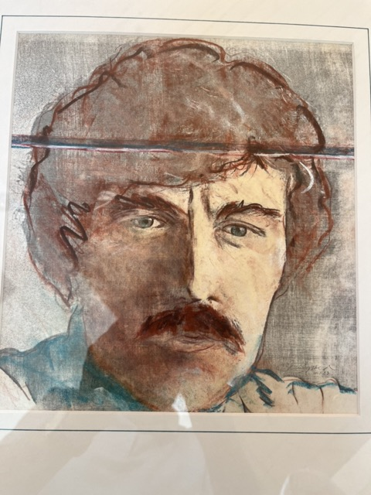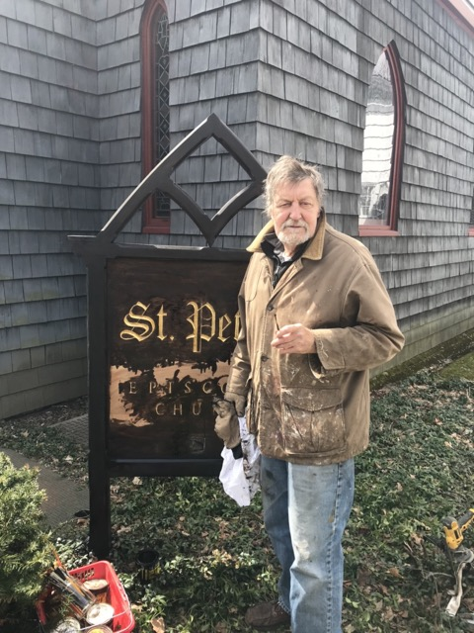

On the left: Self portrait of Paul
On the right: Paul with a paintbrush in his hand and paint on his jacket. He used 23 karat gold leaf to create our beautiful St. Peter’s Church sign.

Paul
Paul, an active member of St. Peter’s Church, is visible to us all in his choir robe singing during Sunday services.
Paul is an artist who has been an integral part of the Cazenovia community for over 55 years.
With a passion for visual communications design, advertising design, and computer graphic design, Paul was a professor at Syracuse University. Additionally, he was a professor of graphic design at Cazenovia College, sharing his expertise and inspiring countless students over the years.
Written by Paul and his daughter

National Pride Month in the Episcopal Church

Why Pride?

In the words of our bishop, the Rt. Rev. Dr. DeDe Duncan-Probe, “LGBTQ people are God’s beloved, made in the image of God, and are our beloved neighbors, friends, clergy and lay leaders of The Episcopal Church.” Episcopalians in Central New York celebrate Pride because we believe in a God of love who created us to love one another. Period.

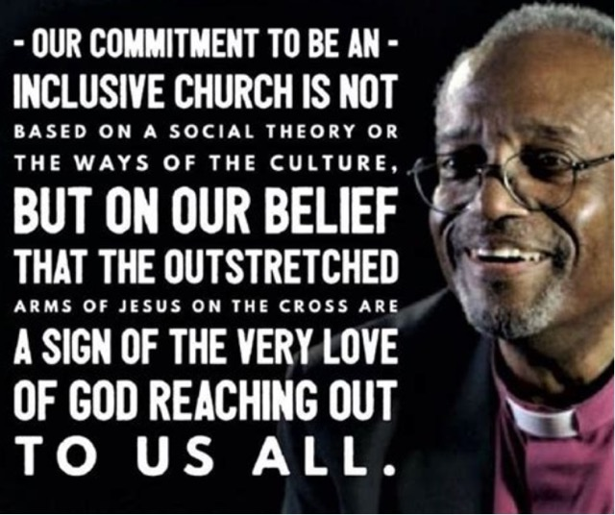

Bible 101 Summer Reading Group

If you would like to learn more about the Bible in relaxing environment, consider the Bible 101 Summer Reading Group. Each month we will read a book and then gather at the church on the last Wednesday of the month at 6:00 pm to discuss it.

Snacks and beverages will be provided. Our schedule is as follows: Reading the Bible Again for the First Time by Marcus Borg (June), Bible Stories for Grownups by Josh Scott (July), and Inspired by Rachel Held Evans (August). Please contact Rev. Rebeca with questions.

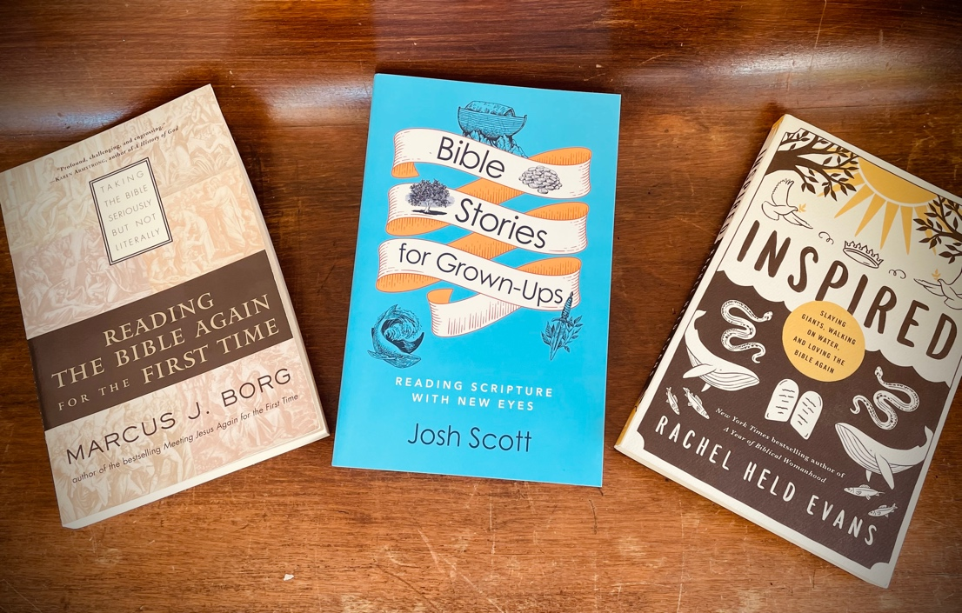

Committee and Ministry News

Greetings from the Vestry!
We gathered for a longer format/retreat meeting on May 13, 2023. This gave us the time and opportunity to dig deeper into issues and get to know each other better. A big event for the day was the vote approving Tim Galbreath to fill the vacancy left by Sandy Petroff’s departure. This vote was per the by-laws (Article II, section 7) which

provide that in “the event of a vacancy, the remaining Vestry Members may elect a qualified person to fill such vacancy until the next Annual Meeting, at which time the Parish shall elect a qualified person to fill the unexpired term.” Welcome Tim!
In other exciting news, I think we have survived the coffee pot crisis with the generous assistance of multiple parishioners. A big maker will replace the old one but we also have two smaller ones to make both a pot of decaf and of regular coffee for smaller gatherings.
Meanwhile, we continue to work towards running in the black. Please prayerfully consider working with us to make that happen by increasing your pledge and your plate donations.
Thank you!
Cynthia Maxwell Curtin,
Senior Warden

Music Ministry

Notes from the Music Gallery
We just celebrated a glorious Pentecost. Our choristers/musicians were a wonderful addition to the singing and liturgy. Beverly and Amy, on violins and Steve on cello added richness to the music.
Choir will be in recess starting June 11th, but members will be singing along with the congregation every Sunday.
We will conclude the season with Mary Brahe’s anthem: “Bless This House”
Blessings!
Written by Ida

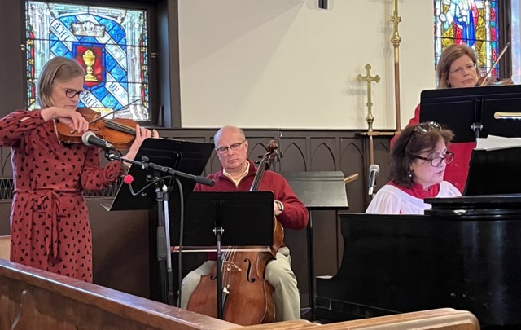

Choir––the beating Heart of St. Peter's Church
Rev. Rebecca likes to say that St. Peter’s is a little church with a big heart! Our choir fits that description as well. In Marti’s words-
“I came to St. Peter’s in the early 90’s and, almost immediately, joined the choir. Doris Holmes was my alto buddy!
As the choir grew and changed directors, I continued to sing and even joined the bell choir. I learned more about reading notes and timing that I never knew before and it has carried me through to this day.
When our dear Ida became the Music Director, she brought much joy and laughter to our practice.
Choir is a family, a camaraderie. We are all closely connected, share each other’s joys and sorrows, laugh a lot and learn how to harmonize with various music pieces to which Ida introduces us each week, some old, some new and challenging, but somehow, we make it work.
There are so many more talented and educated musicians in our choir that, sometimes, I feel inferior. But the satisfaction I receive from “making a joyful noise unto the Lord” outweighs that insecurity.
I am truly blessed to be part of this beloved community and thank God for allowing me this channel in which to contribute to the worshiping of our Lord each Sunday.”
Everyone who has a song in her heart or joy in his soul is welcome to join our choir.
Written by Marti

Buildings, Grounds and Gardens Committee

An Update from BG&G
Whereas last year’s efforts focused on Grounds & Gardens with lots of tree work and sprucing up of the Church and Rectory grounds, so far, the 2023 BG&G focus has been on Buildings.
St. Peter’s property holdings include the Church campus on 10 + 12 Mill Street: sanctuary, parish hall spaces and offices plus the Carriage House; The Key and its two 2nd floor apartments on Albany Street; and the Rectory at 2033 Syosset Lane. Compelling septic system/plumbing issues at the Rectory and urgent fixes to boiler problems at the Church campus called for immediate attention. Similarly, Stan has refurbished the rear Key apartment after the departure of the previous tenant. Several items call for capital investments in the near future, including some of the ones mentioned at our last Parish Meeting.
In the meantime, we have some good news. Judy Deforest spearheaded the beautiful renovation of the Women’s bathroom in the parish hall, complete with new fixtures, cabinetry and flooring. A few areas of the Rectory received new soothing paint colors and stair carpeting. (Both of these projects were funded by donations). Rev. Rebecca worked with Stan and Betsy to visualize the repurposing of the former “CRIS” space for use by the congregation, including adult formation classes. The CRIS offices have moved to the former Carriage House conference room space. Existing furnishings have been moved to the new “NW Suite” to create a seating area with sofas (perfect for small group meetings); an adult formation area with table, chairs and large TV screen; and space reserved for a future nursery. The goal is to have all in place by Labor Day. Plans are also afoot to discuss re-design of Columbarium courtyard with better paving, drainage, plantings and (perhaps?) a church bell.
Written by Betsy

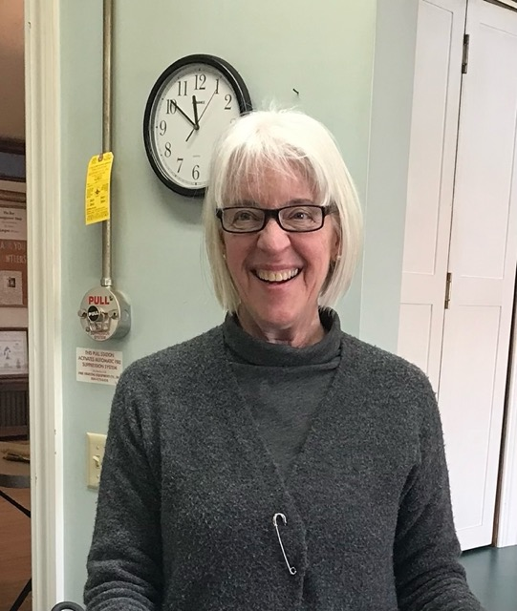
Betsy, the first woman chairperson of the Buildings and Ground committee at St Peter’s Church. The other bustling and busy members are: Tim, Tim, Madeline, Gayonne, Dolli, Trina, Janet, John, Barb, Steve, Don, Rob and Stan. New members are welcome!

News of St. Peter’s and the Greater Community

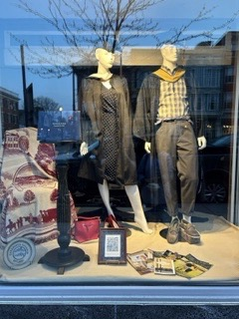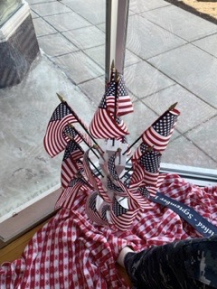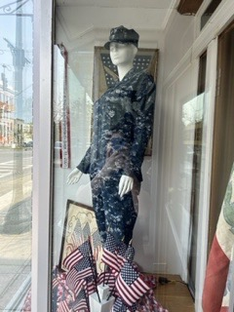

The Windows of the Key

During the month of May, the windows presented a farewell to Cazenovia College featuring 2 graduates in full cap and gown, an original diploma from our own parishioner Betty plus many other pieces of her personal memorabilia collection relating to her college.
A side window is a serious tribute to Memorial Day featuring a digital camo US Navy uniform on a female mannequin plus assorted flags and banners from both World War 1 and 2. Items loaned by Meredith.
Keep an eye on these windows for artistic statements.
By Meredith

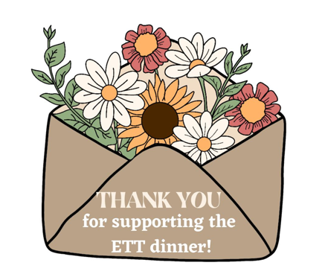

CWR was extremely pleased with the support of the Extending the Table fundraising event. It was sold out at both seatings, and we loved watching people chat and reconnect with friends.

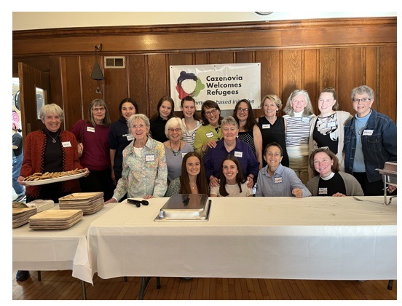
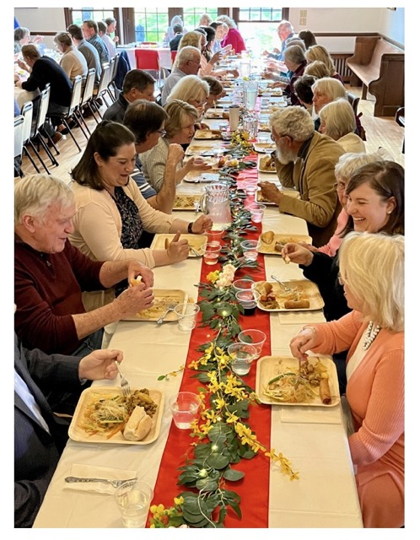

CWR’s next event will be a booth at the Farmers Market on June 17th in support of World Refugee Day (June 20) which is recognized around the world.
If you would like to work with this enthusiastic group, please see Chris or Rev. Rebecca.
By Chris

In June, CazCares is collecting Pasta. Please put your donations in the basket in the parish hall. As always, thank you for your generosity, many people in our Cazenovia community have to rely on it.

CRIS
Cazenovia Resources for Independent Seniors
Karisha, CRIS’s director, reports that CRIS will host an appreciation luncheon for its volunteers or for anyone who would like to be a volunteer. There will be food and surprises!
Right now CRIS needs unopened selfcare products to put in raffle baskets. They would also like sponsors, perhaps families, to help provide selfcare themed baskets, and items, that will be prizes.
After lunch there will be hearing aid tests, eye glass tightenings, and other selfcare stations available to all the luncheon attendees.

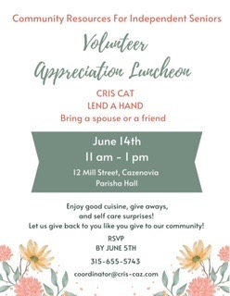

Diocesan News

When?
Saturday, June 10, 2023
Ecumenical Eucharist: 10 am. We’re excited to be partnering with our friends in the Upstate New York Synod of the ELCA for Pride Eucharist! Bishop Lee Miller II will preach and preside and all are welcome to join us!
Parade: 11 am
Where?
We’ll meet in the parade staging area at the Destiny USA parking lot near Solar Street in Syracuse. The Eucharist will take place in this area. You’ll see a HUGE group of parade walkers preparing for the parade; you can’t miss it! If you can’t join us in Syracuse on that day, we’ll be streaming the Pride Eucharist on our Facebook page so that you can celebrate with us.

And in our community
In Cazenovia, the Pride parade and festival will take place on Saturday, June 17. Set up begins at Lakeland Park at 10am and the festival will go until 4. To march, meet in the parking lot behind Cazenovia Library at 11:00 for an 11:30 parade that will lead people through the village and into the park.

Diocesan Safe Church & Formation Day
Please join us for our diocesan Formation and Safe Church Training Day on June 24 at Christ Church in Manlius. We’re reviving something we have done in the past, offering both on-site Safe Church Training as well as workshops for clergy and lay leaders in congregations.
We will begin with a celebration of the Holy Eucharist, then have two workshops in the morning: “Top 10 Things to Keep in Mind for Parish Finances”, offered by The Rev. Steve White, our diocesan treasurer; and “Some Best Practices for Stewardship”, offered by the Diocesan Stewardship Committee.
Lunch will be provided. In-Person Safe Church Training will be offered from 1:30-4:30 pm. It is a requirement for all clergy as well as for all lay leaders who regularly interact with children and youth that they participate in Safe Church Training once every five years.
You may attend the entire day, just the morning sessions, or just the afternoon Safe Church Training.
We are asking for a $10 registration fee to help offset the cost of the day. Many thanks for Christ Church, Manlius for hosting!

Schedule for the day:
- 9:00-9:45 Welcome, Celebration of Holy Eucharist – Nativity of St. John the Baptist
- 10:00-11:00 Workshop 1: Steve White, “Top 10 Things to Keep in Mind for Parish Finances”
- 11:15-12:15 Workshop 2: “Some Best Practices for Stewardship”, Diocesan Stewardship Committee
- 12:15-1:15 Lunch
- 1:30-4:30 Safe Church Training
- 4:30 Brief Closing Prayer & Blessing

Calendar

Events in June

- 10:00 am Bone Builders (Parish Hall)
7:00 pm Choir Practice
4 10:00 am Trinity Sunday Service, followed by Coffee Hour (Parish Hall)
5 10:00 am Bone Builders (Parish Hall)
8 10:00 am Bone Builders (Parish Hall)
7:00 pm Choir Practice
10 7:00 pm Diocesan Pride Parade (starts at Destiny Mall)
11 10:00 am Sunday Service led by The Rev. Alan Smith, Coffee Hour
2:00 pm Student Recitals (Fellows Hall)
12 10:00 am Bone Builders (Parish Hall)
5:15 pm Volunteer Day at the Friendship Inn
7:00 pm AA Meeting (Parish Hall)
14 10:00 am CRIS Volunteer Luncheon (Fellows Halls)
15 10:00 am Bone Builders (Parish Hall)
17 10:30 am Cazenovia Pride Parade (meets at 10:00 behind library)
18 10:00 am Father’s Day, Sunday Service followed by Coffee Hour (Parish Hall)
19 Juneteenth, Parish Office closed
20 10:00 am Bone Builders (Parish Hall)
21 7:00 am Vestry Meeting (library)
22 10:00 am Bone Builders (Parish Hall)
24 9:00 am Diocesan Safe Church (Christ Church, Manlius)
25 10:00 am Mass on the Grass followed by Coffee Hour
26 10:00 am Bone Builders (Parish Hall)
28 6:00 pm Bible 101 Summer Reading Group
29 6:00 pm Eucharist in Celebration of Feast Day of St. Peter and Paul

__________________________________________________________________________________________

Copyright © 2023 St. Peter’s Episcopal Church, all rights reserved

Our mailing address is:
St. Peter’s Episcopal Church
10 Mill Street
Cazenovia, NY 13035
315-655-9063

Email us at:
parishoffice@stpeterscaz.org
Find us at:
www.stpterscaz.org

