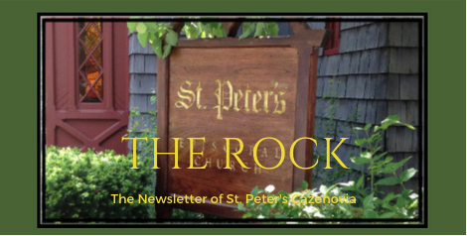

April 2023

Prayer for our Children

God, our hearts are broken with pain at the senseless deaths caused by gun violence. Families mourn, children live in fear, and some in our nation respond by arming themselves with more guns with greater capacity to end life… We ask that you touch our hearts with your love, heal our brokenness, and turn us away from violence toward peace. Amen
From The Sisters of Mercy, Hermanas de la Misericordia

St. Peter’s News

A Message from our Rector

Dear Beloved in Christ,

As I write this to you, I am reeling from the news out of the South—the devastation wrought by the tornadoes in Mississippi and Alabama and the horrifying shooting in Nashville. The past few days, for me, have been filled with prayer for all of those impacted and for all of us who follow Christ. The words of Psalm 25 have been in my mind, and I have been beseeching God to show me, and the nation, the right path. However, words seem so hollow right now. It is at times like this that we can begin to feel hopeless, and it is in such times that we lean into our faith. While I don’t have a one-size-fits-all answer, I do believe that our actions are informed by our faith. This is why it is so important to become clear about what we truly believe and to recognize how the life, death, and resurrection of Jesus Christ inform that faith, and in turn how we live. My prayer is for all of us to become aware of how we are called to act in such times. The highs and lows of Holy Week mirror the highs and lows of life and remind us that God is still present even when all seems lost. May we let God’s love guide us:

O God, you made us in your own image and redeemed us through Jesus your Son: Look with compassion on the whole human family; take away the arrogance and hatred which infect our hearts; break down the walls that separate us; unite us in bonds of love; and work through our struggle and confusion to accomplish your purposes on earth; that, in your good time, all nations and races may serve you in harmony around your heavenly throne; through Jesus Christ our Lord. Amen. (Prayer for the Human Family, BCP p. 815)

Love and peace,
Rev. Rebecca

Holy Week and Easter

Holy Week Worship

During Holy Week we gather as a faith community to journey with Jesus to Jerusalem, to stand with him before his accusers, to walk to Golgatha, to kneel at the foot of his cross. Finally, on Easter Sunday, we will joyfully celebrate the resurrection of Christ, lifting our voices in praise of the hope that is ours and the world’s. We welcome to join us for one or all of these meaningful services.

A Prayer for Easter
Almighty God, who through your only-begotten Son Jesus Christ overcame death and opened to us the gate of everlasting life: Grant that we, who celebrate with joy the day of the Lord’s resurrection, may, by your life-giving Spirit, be delivered from sin and raised from death; through Jesus Christ our Lord, who lives and reigns with you and the Holy Spirit, one God, now and for ever. Amen.
From The Anglican Compas
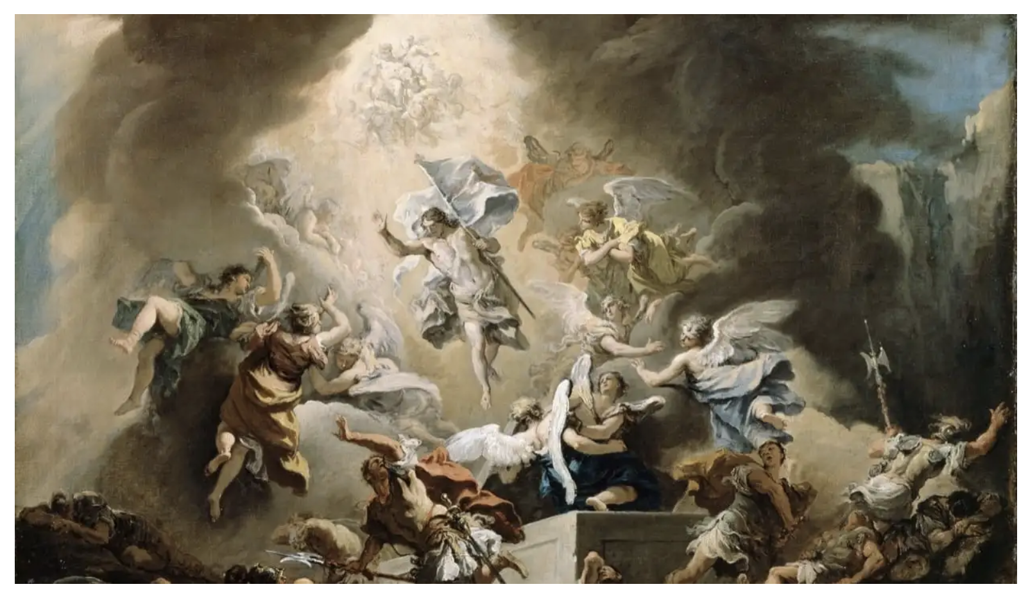

The Resurrection, Sebastiono Ricci, 1715
Photo credit: Dulwich Picture Gallery

The Season of Easter

“Easter Sunday is only the beginning.

A great fifty-day feast (known as “Eastertide,” “Easter Season,” or “Easter Time,” as well as “Paschaltide,” “Paschal Season,” or “Paschal Time”) kicks off on Easter Day. In the Church Year, this is quite literally fifty days of feasting.

Easter is the high point of the Church Year. So it makes sense that we would party for so long. After all, the main point of the whole gospel is to prepare us for an eternal celebration and feast.
This is reflected in the fact that our Lenten fast only lasts forty days (not including Sundays), while Easter is fifty days. Fasting will pass away, as Jesus said, but the Great Feast of the Lamb will last for ages of ages (a Hebrew into Greek idiom for eternity).
Why fifty days of Easter Time? Its actually quite simple. After the resurrection, Jesus spent forty days on earth before he ascended, and then there were ten more days after that before the Day of Pentecost. “
From “A Rookie Anglican Guide to Eastertide”, The Anglican Compass

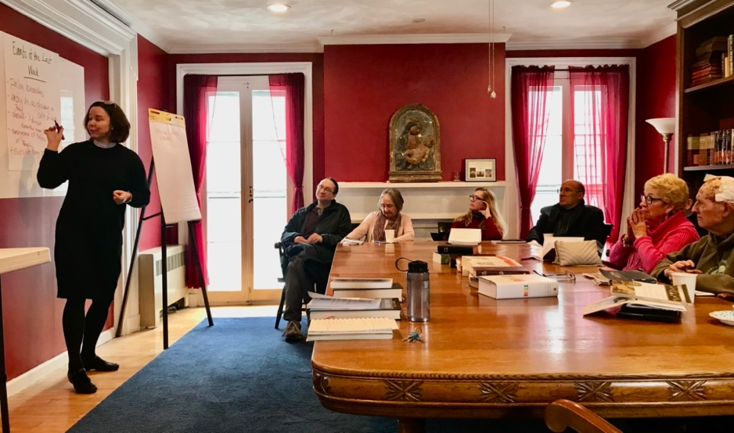

The first of our weekly Bible studies during Lent

Music Ministry

Notes from the Music Gallery
As Easter is approaching, we await the Resurrection Day and are planning for the celebration of Christ’s rising from the dead.
Palm Sunday will start with a gathering in the Parish Hall, with music and plams. Jessica Tumajyan will join the choir and congregation on the violin. The anthem, “Hosanna Loud Hosanna”, by Jeannette Threlfall, will be the center piece. The end of the service is a quiet preparation for Holy Week.
Holy Week has canticles and quiet music appropriate for the Lenten Season.

As triumphant as Easter is, our Easter music will match. Our Easter celebration will include a first rate String Quartet and will be featuring music by Mozart, Corelli, as well as choir anthems.
Guest singer and musicians will join in fir the celebration. The service of Resurrection will be filled with sung Alleluias! The anthem will be: “Christ the Lord is Risen Today” by Anna Laure Page.

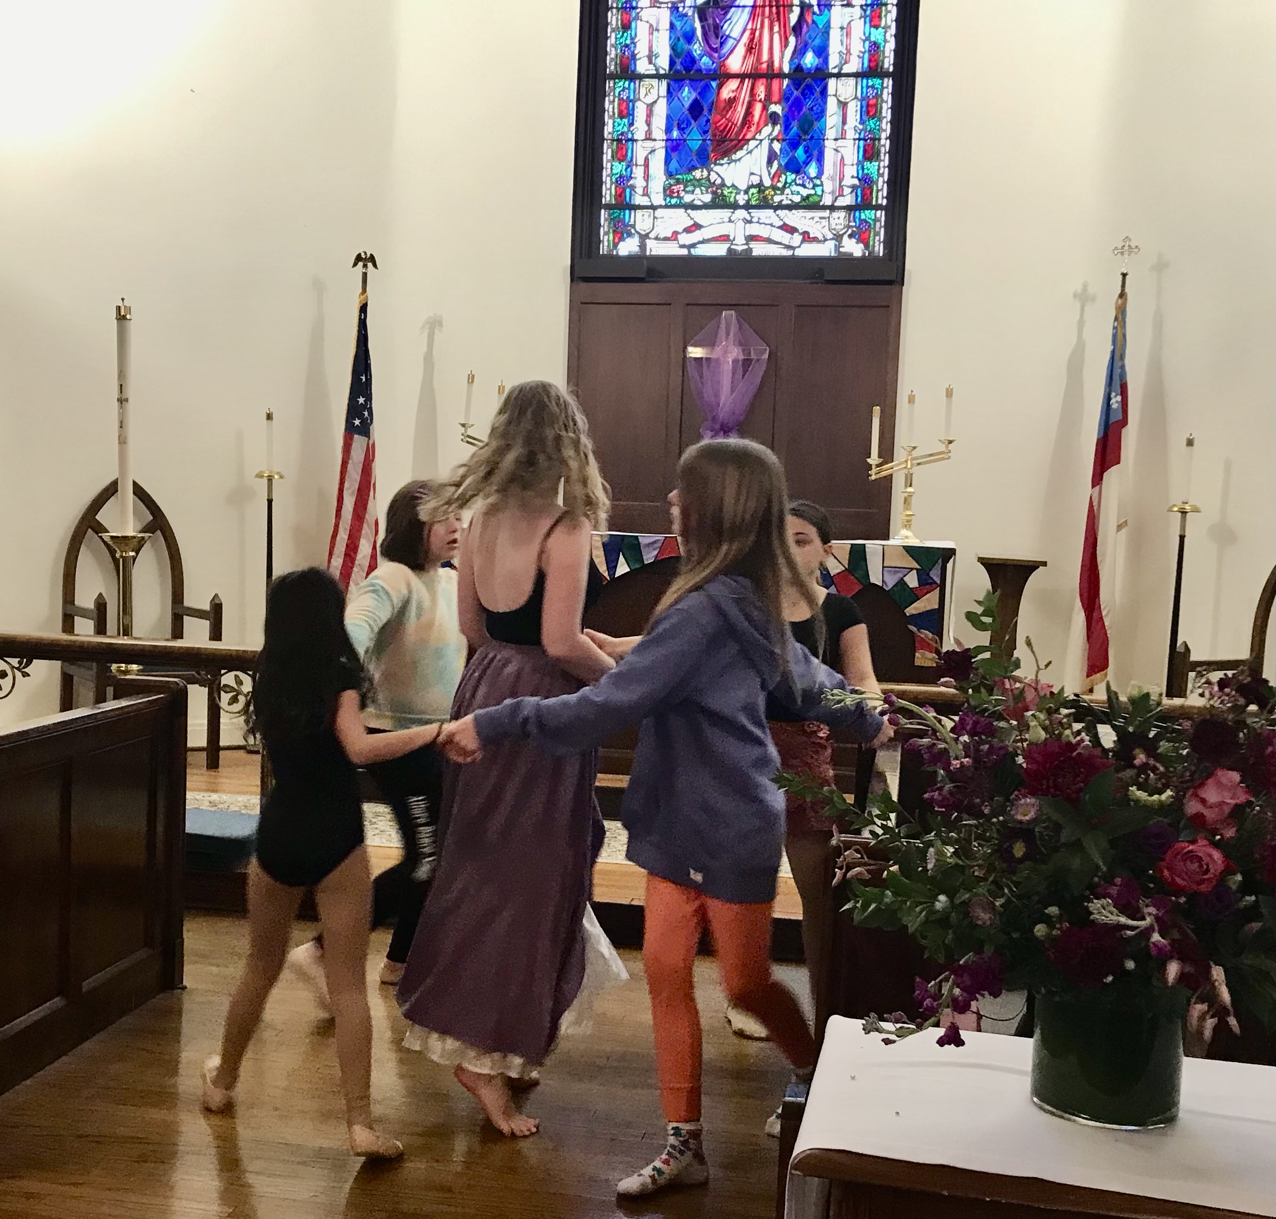

Liturgical Dance Performance

The Gospel came alive during our March 19th Sunday service, through the art of Liturgical Dance, choreographed by our own, Suzanne.

Suzanne explains why she thinks liturgical dance belongs in church this way- “When people ask me why I think it's so important to clarify and to amplify the Gospel's message through dance, I've learned simply to quote Psalms 149:3-4, ‘Let them praise his name with dancing and make music to him with timbrel and harp. For the Lord takes delight in his people; he crowns the humble with victory.”’

A Big Thank you to these 8 wonderful dance students from Cazenovia’s Allure Dance Studio for bringing these choreographic images to life.

Vestry

Greetings from the Vestry Corner!

The Vestry’s March meeting was quite productive. One highlight was the Vestry’s approval of some proposed changes to the bylaws. These changes will be distributed to all in advance of a special meeting in which we will vote on the proposed changes. In addition to correcting some minor format/typos, substantively the Vestry is proposing changing the Nominating Committee to increase input from parishioners and to solidify succession planning for warden positions. The proposed new language is as follows:

The Nominating Committee shall consist of the Warden whose term is not expiring, who shall serve as chair, a Vestry Member whose term is expiring, and two members of the Parish who are not Wardens or Vestry Members. The Nominating Committee should consider candidates for each vacant Vestry position from outside of the Vestry. Regular nominations for Wardens will be from among those persons who have served on the Vestry (including service as the Junior Warden) during the previous year. It is expected that no Warden or Vestry Member shall serve more than a total of six consecutive years on the Vestry (including any service as a Warden).

The Vestry also proposes to clarify voting procedures at the annual meeting as follows:

In the balloting at the Annual Meeting, each position must be elected by a majority vote. This vote can be by acclamation only after the presiding officer asks if there is anyone who desires a vote by secret ballot. If any one person does so desire, then the vote will be conducted by secret ballot. If there is no such desire, the vote can be by acclamation.

Thank you to all who serve God in this Church, in your family, this community and the world beyond.

Faithfully Yours.
Cynthia Maxwell Curtin

News of St. Peter’s and the Greater Community

News of St. Peters and the Greater Community

News from the Key
Warm weather and the warmth of Meredith and Dolli in managing the Key are keeping customers and consigners happy. Meanwhile, there is still an active search going on for a new executive director.
New items continually come into The Key, so do come and shop!
Donations of seasonal clothing and small furniture items are always welcome. Supporting the Key with your donations supports St. Peter’s Church and our community.
Come and check out our Dots: Blue Dot–50% off, Red Dot–75% off, and there is also our 1$ dollar rack!
Store Hours:
Wednesday: 11:30am-4:00pm
Thursday: 11:30am-4:00pm
Friday: 11:30-4:00pm
Saturday: 11:30am-4:00pm

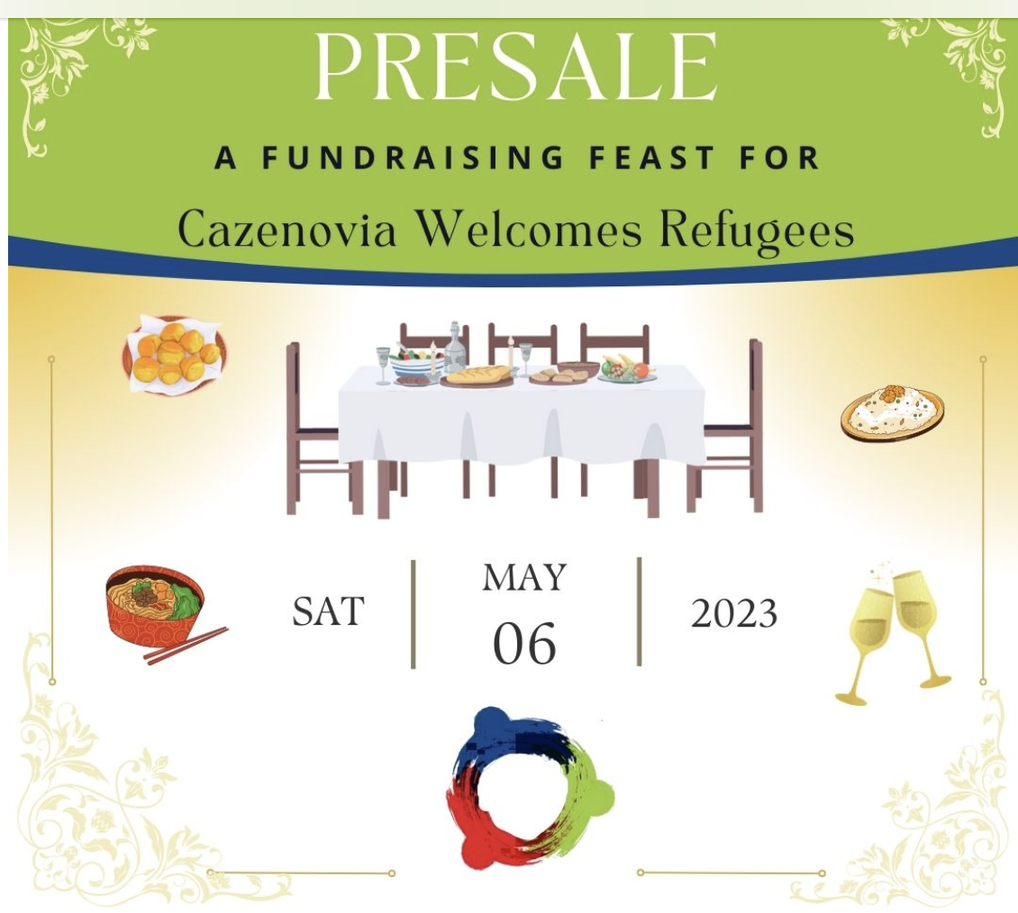

St. Peter’s Church will again be the site for this wonderful fundraising event. Many volunteers will be needed to welcome and guide the guests, set up the tables, wait on tables, clean up, take compostables to the landfill, etc. This year there is a CWR volunteer coordinator who will work with us. If you would like to support this dinner by volunteering please let Chris know.
There will be 2 seatings of the Extending the Table Feast. Tickets will be available starting April 1 at 20 East, J.S. Hight & Sons and at Matthew’s Salon. Tickets will also be available online (https://cazwelcomesrefugees.org/events.html)

The food is delicious, the cause is stellar, and volunteering is fun!

The food item that we are collecting for Caz Cares in April is spaghetti sauce.
During the month of April, Caz Cares is also holding a infant and toddler disposable diaper special collection. There is a particular need for larger sizes.
Please put your items for Caz Cares in the basket in the Parish Hall.
Thank you!

St. Peter's is partnering with CRIS (Community Resources for Independent Seniors) to address the important topic of planning for the end of life. While this is not an issue that most people want to ponder, it is important and helpful to have plans in place. With a wide range of speakers, the presentations will be held on the fourth Monday of the month in Cazenovia Library's Betsy Kennedy Community Room from 10 am –12 pm. There will be time for conversation and questions.

Beyond the Diocesan

Tornado Relief–What Can We Do?

When asked this question, Anne, our church member who worked with the Red Cross after Hurricane Ian, said:
Hearing of the tornado devastation on the evening news leaves many of us with a sense of helplessness, especially as we sit in the comfort of our safe homes and our beautiful community. That feeling was the basis of my decision to join the Red Cross. It’s a wonderful organization and I’ve been grateful for the opportunity to donate time and money.
Volunteers from every state in the nation are currently being deployed to five states that are most impacted by the powerful tornados, hurricanes and deadly floods. The Red Cross provides housing, food, water, and finances as well as spiritual and psychological care. I’m planning to join them in a couple of weeks.
See below for a Red Cross request for financial assistance. I would imagine that several people in our congregation would appreciate an opportunity to donate to the recovery efforts.

According to Bishop Brian R. Seage, Diocese of Mississippi, the best way to help with tornado recover efforts right now is with financial donations.
Via Mail - Checks may be mailed to the Diocesan Office,
PO Box 23107, Jackson, MS 39225.
Please designate in the memo section of the check "Tornado Relief" and/or "Chapel of the Cross Rebuilding", and include your name and mailing address for acknowledgment.

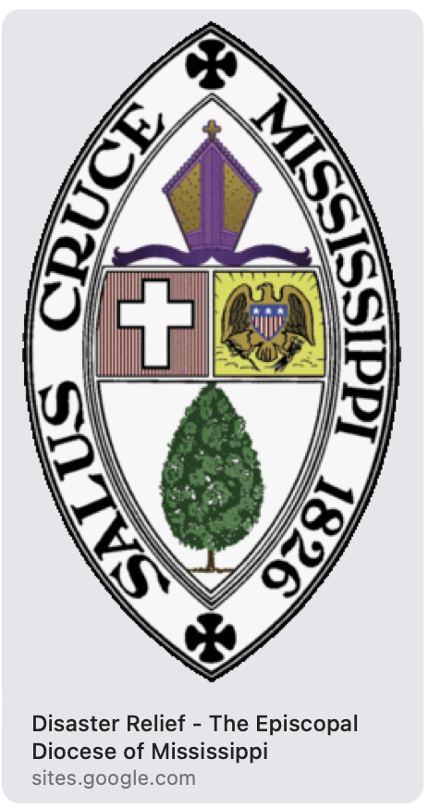

Calendar

Events in April
12 7:00 pm Vestry Meeting
13 10:00 am Bone Builders (Parish Hall)
7:00 pm Choir Practice
16 10:00 am Sunday Service, followed by Coffee Hour (Parish Hall)
17 10:00 am Bone Builders (Parish Hall)
19 10:00 am Bone Builders (Parish Hall)
7:00 pm Choir Practice
23 10:00 am Sunday Service, followed by Coffee Hour (Parish Hall)
24 10:00 am Bone Builders (Parish Hall)
10-12 am CRIS series on Aging at the Cazenovia Public Library
27 10:00 am Bone Builders (Parish Hall)
7:00 pm Choir Practice
30 10:00 am Sunday Service, followed by Coffee Hour (Parish Hall)

__________________________________________________________________________________________

Copyright © 2023 St. Peter’s Episcopal Church, all rights reserved

Our mailing address is:
St. Peter’s Episcopal Church
10 Mill Street
Cazenovia, NY 13035
315-655-9063

Email us at:
parishoffice@stpeterscaz.org
Find us at:
www.stpterscaz.org

